**R1058 - Rumination for May. 11, 2025 [Mother’s Day]**

The **T**ext: *Her children arise up, and call her blessed; her husband also, and he praiseth her.* Pro. 31:28

The **T**hots:

1. **Creation and Eve, the Mother of all living**
2. **Eve** was Created to be the Mother of all living. Gen 3:20

*And the rib, which the LORD God had taken from man, made﻿﻿ He a woman, and brought her unto the man*

*And Adam called his wife’s name Eve; because she was****the mother of all living****.*

1. Eve, **the Woman**, was brought to be with **Adam** to be the Mother of all Living: Gen. 2:23

*Adam said, This is now bone of my bones, and flesh of my flesh: she shall be called Woman﻿﻿,*

*because she was taken out of Man.*

1. But because of **Adam’s and Eve’s Sin**, Eve was to be the Mother of all living with Sorrow. Gen. 3:16

*Unto the woman He said, I will greatly multiply thy sorrow and thy conception; in sorrow thou shalt bring forth children; and thy desire shall be to thy husband, and he shall rule over thee.*

1. **Christ and Mary – the Mother who was a Virgin.**
2. The **P**rophecy of a Virgin Birth: Isa. 7:14
3. *Therefore the Lord Himself shall give you a sign; Behold, a virgin shall conceive,*

*and bear a son, and shall call﻿﻿ His name Immanuel.*

1. *Behold, a virgin shall be with child,﻿﻿ and shall bring forth a son,*

*and they shall call His name Emmanuel, which being interpreted is, God with us.* Mt. 1:23

1. The **P**roduct of a Virgin Birth: Mt. 1:18

*Now the birth of Jesus Christ was on this wise: When as His mother Mary was espoused to Joseph,*

*before they came together, she was found with child of the Holy Ghost.*

1. Jesus was **C**onceived of the Spirit:Mt. 1:20

*Behold, the angel of the Lord appeared unto him in a dream, saying, Joseph, thou son of David,*

*fear not to take unto thee Mary thy wife: for that which is conceived﻿﻿ in her is of the Holy Ghost.*

1. Jesus never **C**alled Mary His Mother:
2. He Called her “*Woman”* at **C**ana: Jn, 2:4

*Jesus saith unto her, Woman, what have I to do with thee? Mine hour is not yet come.*

1. He Called her “*Woman*” at the **C**ross. Jn. 19:26

*When Jesus therefore saw His mother, and the disciple standing by, whom He loved,*

*He saith unto His mother, Woman, behold thy son!*

1. He Called other **C**hristians, “Mother”! Lk. 8:20, 21; Mt. 12:48-50; Mk. 3:33-35

*And it was told Him by certain which said, Thy mother and thy brethren stand without, desiring to see Thee. And He answered and said unto them, My mother and my brethren are these which hear the word of God, and do it.*

1. The **W**isemen **W**orshipped only the Baby in the Mother’s Arm, not Mary! Mt. 2:11

*When…they saw the young Child with Mary His mother, and fell down, and worshipped Him:*

*…when they had opened their treasures, they presented﻿﻿ unto Him gifts; gold…frankincense, and myrrh.*

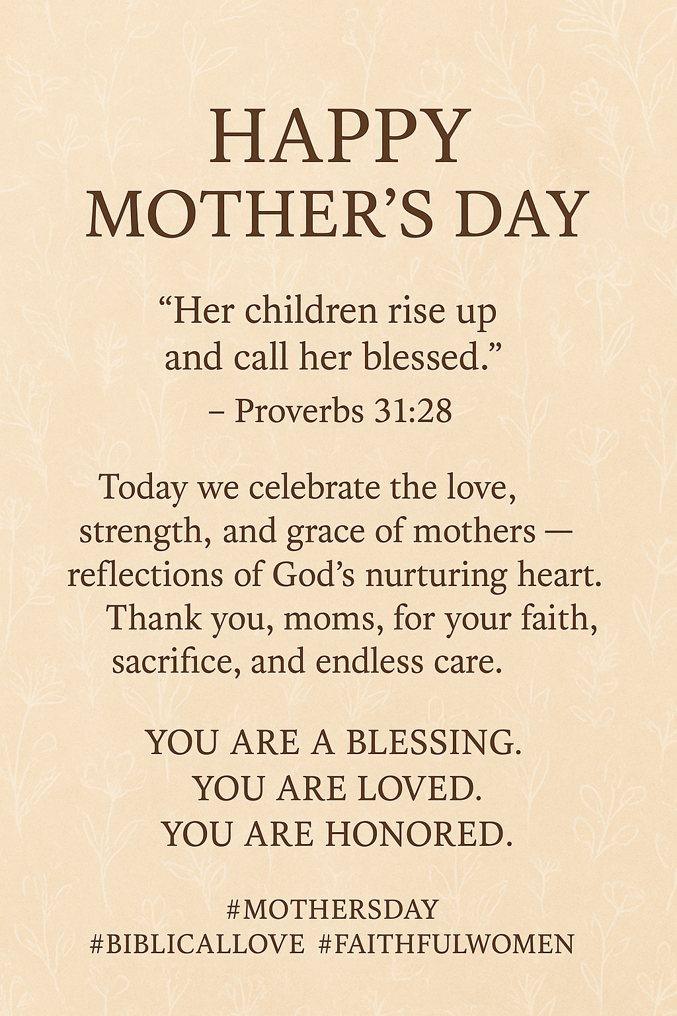

1. **The Children and their Mother**
2. Her Children should **A**rise and **A**cclaim their Mother, even as their father **A**dmires her. Pro. 31:25-**28** *Strength and honour are her clothing; and she shall rejoice in time to come. She is clothed with strength and dignity; she can laugh at the days to come. She openeth her mouth with wisdom; and in her tongue is the law of kindness. She speaks with wisdom, and faithful instruction is on her tongue. She looketh well to the ways of her household, and eateth not the bread of idleness. She watches over the affairs of her household and does not eat the bread of idleness.*

***Her children arise up, and call her blessed; her husband also, and he praiseth her.***

1. Children should also **L**ook after their Mother and **L**isten to her teaching. Pro. 1:8; 6:20

*My son, hear the instruction of thy father, and forsake not the* ***L****aw of thy mother:*

1. **The Christian Child and His/Her Mother**
2. **O**bey your **P**arents: the Christian Child should obey his/her father and mother in the Lord. Eph 6:1

*Children, obey your parents in the Lord, for this is right.*

1. ‘**O**nour your father and mother – A **P**romise is attached: Eph 6:2

*Honour thy father and mother; (which is the first commandment with promise*

*That it may be well with thee, and thou mayest live long on the earth.* Eph 6:3

1. **The Concluding Remark and Reminder to all Children:**
2. A **C**ompassionate Mother will never **F**orget her **C**hildren;
3. And the **C**ommitted God, the **F**ather, never will: Isa 49:15.

***C****an a woman forget her sucking* ***C****hild, that she should not have* ***C****ompassion on the son of her womb?*

*yea, they may forget, yet will I not forget thee.*

**Points To Ponder:** *A* ***M****other spends her life time* ***C****aring for her* ***M****any* ***C****hildren;*

*but her* ***F****ew* ***C****hildren* ***F****ind it* ***C****umbersome to* ***C****are for their One* ***M****other!!*