R854 Rumination for 06th June, 2021 by K.C. Ung
The Theme: Who will lay down Whose Life? berita-bethel-ung.com
The Text: Peter said…Lord…I will lay down my life for Thy sake.
Jesus answered him, Wilt thou lay down thy life for My sake? Jn. 13:37-38
The Thots:
- Peter’s Important Conversation with the Lord. Jn. 13:36-38
Peter said…Lord…I will lay down my life for Thy sake
- Peter’s Inquiry – Lord, whither goest Thou?
- Jesus’ Reply – Whither I go, thou canst not follow Me now; but thou shalt follow Me afterwards.
- Peter’s Insistence – Lord, why cannot I follow Thee now? I will lay down my life for Thy sake.
- Jesus’ Retort – Wilt thou lay down thy life for My sake?
- Jesus’ Response – Verily, verily, I say unto thee, The cock shall not crow, till thou hast denied Me thrice.
- Peter Boasted like a Cock – I will lay down my life for Thy sake.
- Peter would Be Betrayed by a Cock Crow: The cock shall not crow, till thou hast denied Me thrice.
- The Reality and the Consequence later: Mt. 26:74, 75
- Peter’s Curse and denial: Then began he to curse and to swear, saying, I know not the man.
- And immediately the Cock Crew.
- Peter reCalled the word of Jesus, which said unto him, Before the cock crow, thou shalt deny me thrice.
- Peter realised what happened and he Cried bitterly – And he went out, and wept bitterly.
- Boast not Today what you Will do Tomorrow – Subject it all to His Word and his Will. Jas. 4:13-15 Go to now, ye that say, Today or tomorrow we will go into such a city, and continue there a year, and buy and sell, and get gain: Whereas ye know not what shall be on the morrow. For what is your life?
It is even a vapour, that appeareth for a little time, and then vanisheth away. For that ye ought to say, If the Lord will, we shall live, and do this, or that.:

- The Pertinent Challenge to us –
Jesus answered…Wilt thou lay down thy life for My sake?
- The Example of Christ – He lay down His Life for us!
- I am the good shepherd: the good shepherd giveth His life for the sheep. Jn. 10:11
- As the Father knoweth Me, even so know I the Father: and I lay down My life for the sheep. Jn. 10:15
- Therefore doth My Father love Me, because I lay down My life, that I might take it again. Jn. 10:17

- The Exhortation to Christians “to Die”. Rom. 6:11
Reckon ye also yourselves to be Dead indeed unto sin, but alive unto God through Jesus Christ our Lord.
- Be Baptised into Christ. Rom. 6:3
Know ye not, that so many of us as were baptized into Jesus Christ were baptized into His death?
- By Immersion into Water – Symbolic of Baptised into His death. Rom. 6:3
- By Submersion in Water – Symbolic of Being Buried with Him by Baptism into death: Rom. 6:4a
- By Emersion out of Water – Symbolic of Being as Christ was raised up from the dead Rom. 6:4b
by the glory of the Father, even so we also should walk in newness of life.
- Be Crucified with Christ Gal. 2:20
I am crucified with Christ: nevertheless I live; yet not I, but Christ liveth in me: and the life which I now live in the flesh I live by the faith of the Son of God, who loved me, and gave Himself for me.

- Let Christ Be Magnified in me: Phil. 1:20, 21
According to my earnest expectation and my hope, that in nothing I shall be ashamed,
but that with all boldness, as always, so now also Christ shall be magnified in my body,
whether it be by life, or by death.
For to me to live is Christ, and to die is gain.

- The Profit of being dead with Christ.
- Live to Die Daily:
I protest by your rejoicing which I have in Christ Jesus our Lord, I die daily. I Cor. 15:31
- Put to Death the Deeds of the Law.
For if you live according to the flesh you will die; but if by the Spirit you put to death the deeds of the body, you will live. Rom. 8:13, NKJV

- Be Delivered from the Body of Death. Rom. 7:24-25 24
O wretched man that I am! who shall deliver me from the body of this death?
I thank God through Jesus Christ our Lord.
- Live or Die, we are the Lord’s:
For whether we live, we live unto the Lord; and whether we die, we die unto the Lord:
whether we live therefore, or die, we are the Lord's. Rom. 14:8
O Je sus, Lord and Savior, I give myself to Thee,
For Thou, in Thy atonement, didst. give Thyself for me.
I own no other master; my heart shall be Thy throne.
My life I give, hence forth to live, O Christ, for Thee a lone. T. O. Chisholm
REFLECTIONS FOR THE WEEK R. 854
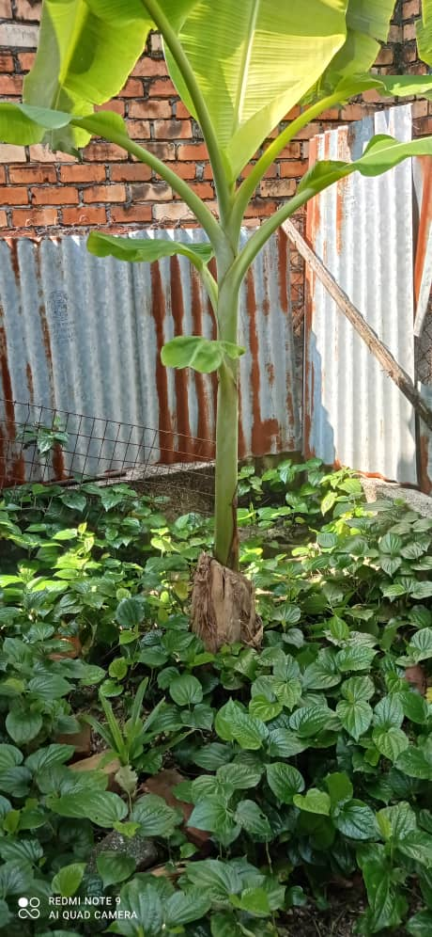
- In my garden was a banana plant which died by itself when it was about to sprout a branch of fruits. I had no choice but to cut it down, leaving behind its stump as it was too strenuous for me to uproot the whole plant. I left it to “die” by itself.
Now two months later, a healthy living plant had sprouted up from the dead plant, healthy as ever and having promise that it would grow into a mature plant to bear fruit.
This reminds me of what Paul meant when he wrote:
Galatians 2:20 – I am crucified with Christ: nevertheless I live; yet not I, but Christ liveth in me: and the life which I now live in the flesh I live by the faith of the Son of God, who loved me, and gave Himself for me.

It also reminds me of the Words of the Lord in…
John 12:24, NKJV – Most assuredly, I say to you, unless a grain of wheat falls into the ground and dies, it remains alone; but if it dies, it produces much grain.

Indeed, there is Gain to come out of Death as Paul wrote,
Phil. 1:21 – For to me to live is Christ, and to die is gain.

Is it therefore worth dying to self that Christ’s resurrected life may live out in and through us – that from henceforth we may ever abide in Him and He in us that we may bear fruit?
John 15:5 – I am the Vine, ye are the branches: He that abideth in Me, and I in him, the same bringeth forth much fruit: for without Me ye can do nothing. REFLECT.

- Ezekiel 37:1-6 -
1 The hand of the LORD was upon me, and carried me out in the spirit of the LORD, and set me down in the midst of the valley which was full of bones, 2 And caused me to pass by them round about: and, behold, there were very many in the open valley; and, lo, they were very dry. 3 And he said unto me, Son of man, can these bones live? And I answered, O Lord GOD, thou knowest. 4 Again he said unto me, Prophesy upon these bones, and say unto them, O ye dry bones, hear the word of the LORD. 5 Thus saith the Lord GOD unto these bones; Behold, I will cause breath to enter into you, and ye shall live:
6 And I will lay sinews upon you, and will bring up flesh upon you, and cover you with skin, and put breath in you, and ye shall live; and ye shall know that I am the LORD.
Ezekiel 37:11-14 -
11 Then He said unto me, Son of man, these bones are the whole house of Israel: behold, they say, Our bones are dried, and our hope is lost: we are cut off for our parts.
12 Therefore prophesy and say unto them, Thus saith the Lord GOD; Behold, O my people, I will open your graves, and cause you to come up out of your graves, and bring you into the land of Israel. 13 And ye shall know that I am the LORD, when I have opened your graves, O my people, and brought you up out of your graves, 14 And shall put My Spirit in you, and ye shall live, and I shall place you in your own land: then shall ye know that I the LORD have spoken it, and performed it, saith the LORD.
The above prophecy was made when historically the nation of Israel felt very dry and dead they were away from God’s Promised Land; they were dry but not dead bones in their land. They were seemingly without hope of restoration. But God gave Ezekiel this vision of the valley of dry bones that came to live when the Spirit came upon them – Israel would be back in their land, and it would flourish and proper again and they would live and be alive once more!
And this is what is happening in and to Israel today. The prophecy is being fulfilled. The Jews have returned to their land and it has grown vibrantly alive. Israel is awaiting the prophecy’s full fulfilment. Do you think God will fulfil it? REFLECT.
Things To Pinder: What God Begins, He will Bring to an End.

