Rumination 832 for Jan. 10, 2021 by K.C. Ung
The Theme: Press toward the Prize. berita-bethel-ung.com
The Text: I press toward the mark for the prize of the high calling of God in Christ Jesus. Phil. 3:14
The Thots:
Intro. What Are Your Pressing Thoughts for the Year 2021? Here are Five (#A-E) to Help you Prepare:
- Forget the Past and Look Forward to the Future. Phil. 3:13-14
Never you mind if you Feel you have Failed to Achieve your Past Purposes:
Brethren, I count not myself to have Apprehended:
- Seek a New Aim for the New Year – this one thing I do…
- Forget… those things which are behind – the Past;
and reaching Forth unto those things which are before – the Prospect;
- Go Forward as Follows…
- Your 2021 Goal: Press toward the mark For the Prize of the high calling of God in Christ Jesus.

- Set your Affection on things Above…If ye then be risen with Christ, Col. 3:1-4
- Seek those things which are Above, where Christ Sitteth on the right hand of God.
- Set your Affection on things Above, not on things on the earth.
- For ye are dead, and your life is hid with Christ in God.
- When Christ, Who is our life, shall appear, then shall ye also appear with Him in glory.

- Fix your Eyes on Christ Jesus.
- Focus your Faith on Chris: Looking to Jesus the Pioneer and Perfecter of our faith, Heb. 12:2, NRSV
- His Set Mission: Who for the sake of the joy that was set before Him
- His Self-Mastery: endured the cross, disregarding its shame,
- His Seated Majesty: and has taken His seat at the right hand of the throne of God. Cf. Heb. 1:3b

- Fix your eyes on the trans-Figured Jesus: Mt. 17:1-8
When they had lifted up their eyes, they saw no man, save Jesus only. Mt. 17:8
- Three Prominent Personalities were Present at the Transfiguration of Jesus. Matt. 17:3, NKJV
And behold, Moses and Elijah appeared to them, talking with Him.
- The Perspective of these People:
- Moses representing OT Saints Redeemed from Egypt. Exo. 15:1, 13, NKJV
Then Moses sang this song…You in Your mercy have led forth the people whom You have redeemed…
- Elijah representing the NT Saints who one day will be Raptured without dying:
Note: Elijah was translated into Heaven without Dying: II Kgs. 2:11
Behold, there appeared a chariot of fire…and Elijah went up by a whirlwind into heaven.
Cf. Then we which are alive and remain shall be caught up together with them in the clouds,
to meet the Lord in the air: and so shall we ever be with the Lord. I Thes. 4:17
- The Preeminent Person Who Remained in their Sight -
And when they had lifted up their eyes, they Saw no man, Save Jesus only. Mt. 17:8
- Our 2021 Goal: He is the head of the body, the church: Who is the beginning,
the firstborn from the dead; that in all things He might have the Preeminence. Col. 1:18

- Fervently Love the Lord. Jn. 21:15-17
- Peter’s Past – He Denied his Lord three times. Matt. 26:72-75
And again he denied with an oath, I do not know the Man.
- Peter’s Present – Peter had to Declare he loved the Lord three times. Jn. 21:15-17
He saith unto him the third time, Simon, son of Jonas, lovest thou Me?...
And he said unto him, Lord, Thou knowest all things; Thou knowest that I love Thee.
- Peter’s Pastoring Duty - Jesus saith unto him, Feed My sheep.
The elders which are among you I exhort, who am also an elder…Feed the Flock of God… I Pet. 5:1, 2
- Our 2021 Goal: If ye love Me, keep My commandments. Jn. 14:15

- Faithfully Labour for Him. I Cor. 15:58
- Our 2021 Goal: Continue to be Faithful in your Labour for Him,
Therefore, my beloved brethren, be ye stedfast, unmoveable,
- Cease not, Always Abounding in the work of the Lord,
- Your Award will Come ultimately… as ye know that your Labour is not in vain in the Lord.
Cf. I have Fought a good Fight, I have Finished my course, I have kept the Faith:
Henceforth there is laid up for me a crown of righteousness, which the Lord, the righteous judge,
shall give me at that day: and not to me only, but unto all them also that love his appearing. II Tim. 4:8

- Remember, Forsake not your Rest in your Labour for Him - Mk. 6:31
- Come unto Me, all ye that labour and are heavy laden, and I will give you rest. Mt. 11:28
- And He said unto them, Come ye yourselves apart…and rest a while: Mk. 6:31
- Our 2021 Goal: Remember the sabbath day, to keep it holy. Exo. 20:8
When He had given thanks, He said… this do in Remembrance of Me. I Cor. 11:24
When to the cross I turn mine eyes And Rest on Calvary,
O Lamb of God, my sacrifice, I must Remember Thee- James Montgomery

REFLECTIONS FOR THE WEEK R. 832
- Below is a morning devotion extracted from Samuel Bagster’s Daily Light for New Year Day, 1st January. The uniqueness of the Daily Light Reading is that every word of its text is from the Lord’s Word itself arranged into a very relevant and pertinent message for the Reader.

Meditate and Reflect on it to see how the Lord prepares you to face 2021 with His help and the Guidance of the Word of God, the new Challenges of Covid-19 this year,

Psalm 119:105 - Thy word is a lamp unto my feet, and a light unto my path.
Psalm 119:11 - Thy word have I hid in mine heart, that I might not sin against thee.

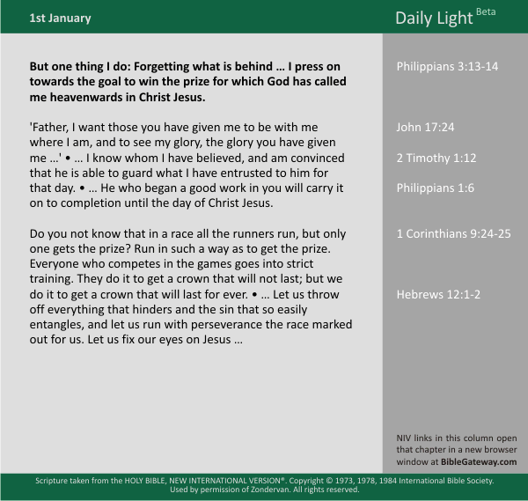

Press Forward this year of 2021 with your eyes Fixed on Jesus and your Feet guided by the Word of God to walk in the Path He has Planned out for you. REFLECT.

- In the Rumination, Five things were proposed to guide you into the New Year 2021,
- Forget the Past and Look Forward to the Future. Phil. 3:13-14
- Fix your Eyes on Christ Jesus. Heb. 12:2
- Fervently Love the Lord. Jn. 21:15-17
- Faithfully Labour for Him. I Cor. 15:58
- Forsake not your Rest in your Labour for Him - Mk. 6:31
Go over them again and REFLECT.

Points To Ponder: Your Year will be Blessed when You Give Him Your Best.

