R827 (77)_Rumination for Dec 06, 2020
The Theme: Samson’s last hours berita-bethel-ung.com
The Text: Samson called unto the LORD… “strengthen me; I pray thee, only this once” Jud. 16:28
The Thots:

Intro.: Compare and Contrast the Last Hours of Samson with the Last Hours of Jesus.

- The Person
- Samson: He was given to deliver Israel out of Slavery. Jud. 13:5b
For, lo, thou shalt conceive, and bear a son…he shall…deliver Israel out of the hand of the Philistines.
- Jesus: He was given to save sinners from their Sins. Matt. 1:21
She shall bring forth a Son, and thou shalt call His name JESUS: for He shall save His people from their sins

- The Posture
- Samson: His hands were outstretched to the left and right. Jud. 16:29
Samson took hold of the two middle pillars…of the one with his right hand, and of the other with his left.
- Jesus: His hands were outstretched, being crucified on the cross. Lk. 23:33
There they crucified Him, and the malefactors, one on the right hand, and the other on the left.

- The Prayer
- Samson: He prayed to God to enable him to avenge his enemies. Jud. 16:28
O God, that I may be at once avenged of the Philistines for my two eyes.
- Jesus: He prayed to God to forgive His enemies. Lk. 23:34
Then said Jesus, Father, forgive them; for they know not what they do.
When we were enemies, we were reconciled to God by the death of His Son. Rom. 5:10

- The Petition
- Samson: He petitioned God twice, to be with him, and to strengthen him for this once. Jud. 16:28
Samson … said, O… GOD, remember me, I pray thee, … I pray thee, only this once, O God…
- Jesus: He addressed God twice, and asked why for once God was forsaking Him. Matt. 27:46
Jesus cried with a loud voice, saying, … My God, my God, why hast Thou forsaken Me?

- The Parting
- Samson: He bowed down and Committed Suicide by pulling the temple down with him Jud. 16:30
He bowed himself with all his might; and the house fell upon the lords, and… all the people … therein.
- Jesus: He bowed His head and Committed His Spirit back to His Father.
Jesus said, "It is finished." With that, He bowed His head and gave up His Spirit. Jn. 19:30, NIV
Jesus called out … "Father, into Your hands I commit My spirit." Lk. 23:46, NIV

- The Product:
- Samson: The end result of his life was more deaths.
So the dead which he slew at his death were more than they which he slew in his life. Jud. 16:30
- Jesus: The end result of His death was more dead sinners brought to life. Jn. 12:24
I tell you the truth, unless a kernel of wheat falls to the ground and dies, it remains only a single seed.
But if it dies, it produces many seeds.

Conclusion:
- Samson called upon God to Remember Him, and God did:
And Samson called unto the LORD, and said, O Lord GOD, remember me.
- The thief on the cross, called on Jesus to Remember him, and Jesus did.
He said unto Jesus, Lord, remember me when Thou comest into Thy kingdom.
- Jesus calls upon His Church to remember Him, do we?
Take, eat: this is My body, which is broken for you: this do in remembrance of Me. I Cor. 11:24
This cup is the new testament in My blood: this do ye…in remembrance of Me. I Cor. 11:25

Thy body, broken for my sake, My bread from heaven shall be;
The cup of blessing I will take, And thus remember Thee.
Remember Thee, and all Thy pains. And all Thy love to me;
Yea, while a breath – a pulse remains Will I remember Thee.
Montgomery

REFLECTIONS FOR THE WEEK: R. 827
- Last week an event took place in my garden that reminded me of Samson, that legendary man of strength. He grew up as a Nazarite, straight and simple, but soon grew up to be a man of great strength, headstrong in his life-style with little or no self-control, wanting his ways most of the time.
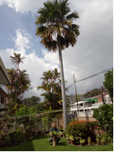It reminds me of the tall palm tree in my garden. It is straight and tall, grown to a height of sixty feet or more, higher than a double-story house. However, lately its exposed roots seem to indicate that it may pose a potential danger of it falling and bringing destruction to the cars parked on the roadside and even may cause damage to the neighbouring houses nearby. Hence, I was advised to cut it down before it causes havoc to the neighbourhood.

It reminds me of how Samson grew up and out of the Spirit’s control in pursuing his own lustful ways that finally brought him to his downfall, and in doing so caused more destruction to his Philistine enemies in his death than in his life time.
And Samson said, Let me die with the Philistines. And he bowed himself with all his might; and the house fell upon the lords, and upon all the people that were therein. So the dead which he slew at his death were more than they which he slew in his life. (Jud. 16:30)

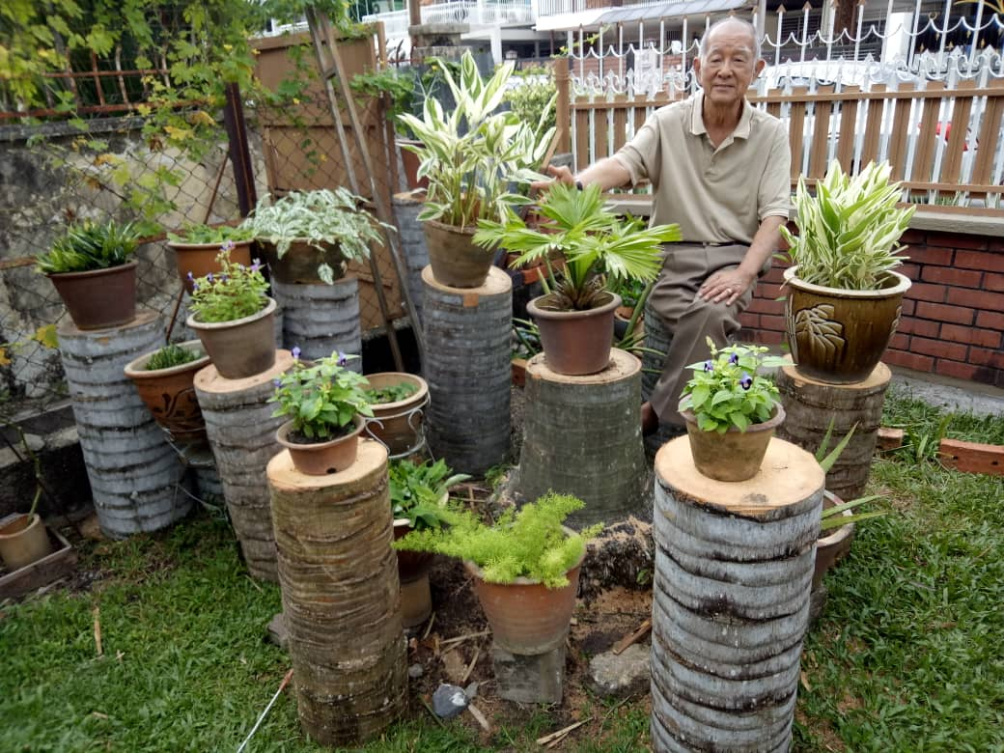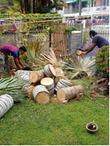Today, this tall, majestic palm tree is no more – sawn into pieces. Last Tuesday, with the services of three men using a crane and a motorized saw. it was felled to the ground and its trunk cut into stumps to serve as flower-pot stands or seats in the garden.

This gigantic palm tree has a “twin” grown in a pot (centre of photo =>). Today, it is just a little taller than a foot growing in the same pot – it is a mere potted plant, though the same age as its felled gigantic “sibling”. Lesson: when a seed is planted in good soil, like the tiny mustard seed, it can grow up into a gigantic height of a tree, but when planted in a pot confined in its growth, it will grow over the years but it will be short and stunted.
To grow well and developed into a strong tree you need to grow in the good soil of the Word of God, then only in your growing years you will be strong and bear fruit. (Jn. 15 cf. Mt. 13:32 – [The mustard seed] indeed is the least of all seeds: but when it is grown, it is the greatest among herbs, and becometh a tree, so that the birds of the air come and lodge in the branches thereof.).
Are you a giant fruit-bearing tree or a dwarf stunted Christian over the years? REFLECT

- After listing in detail in Heb. 11:4-31, the exploits of the heroes and heroines of faith, the apostle summarised the list with a reference to six men. And what shall I more say? for the time would fail me to tell of Gedeon, and of Barak, and of Samson, and of Jephthae; of David also, and Samuel, and of the prophets (Heb. 11:32). Five of the mentioned were judges who lived in those dark days where every man did that which was right in his own eyes (Jud. 17:6; 21:25). Surprisingly, among them was Samson! Would you ever list him among those heroes of faith named earlier? You might not; he could only be reckoned one by God’s sovereign grace! If he was not worthy, could you ever think that you yourself could be worthy to be in the list? Samson lived in the days not much different from ours today. Can God still use the Christian lawmakers (judges) in our country to achieve justice, integrity, righteousness for our citizens today? Samson could only be reckoned to be a hero of faith by virtue of God’s sovereign grace. Could our country’s Christian lawmakers prove themselves worthy of such virtue? REFLECT.
Points to Ponder: We are not Worthy by our Works, but only Reckoned so by God’s Grace!

