R829 Rumination for Dec 20, 2020
The Theme: Unto US A Child Is Born, Unto Us A Son Is Given berita-bethel-ung.com
The Text: For unto us a child is born, unto us a son is given. Isa. 9:6
The Thots:
- Unto Us A Child Is Born.
- The Forecast Isa. 9:6
Unto us a child is born, unto us a son is given: and the government shall be upon his shoulder…
- For the Messiah’s and our Time: Unto us Child is born, unto us a Son is given: Isa. 9:6a
The Meaning: i. A Child is born – The Humanity of Jesus
ii. A Son is given – The Deity of Jesus
- For the Millennium: […shall reign with Him a thousand years.] Rev.20:6
The government shall be upon His shoulder: Isa. 9:6b
and His name shall be called Wonderful, Counsellor, The Mighty God,
The everlasting Father, The Prince of Peace

- The Fulfilment.
- The Confirmation: Behold, a virgin shall be with Child, and shall bring forth a Son, Matt. 1:23
- The Conception: …that which is conceived in her is of the Holy Ghost. Matt. 1:20
- The Concept: i. The Child’s Humanity – thou shalt call His name JESUS:
for He shall save His people from their sins. Mt. 1:21
ii. The Child’s Deity: they shall call His name EMMANUEL,
which being interpreted is, God with us. Mt. 1:23

- The Fruit: God so loved the world, that He gave His only begotten Son… Jn. 3:16
- The Consequence: that whosoever believeth in Him should not perish, but have everlasting life.
- The Challenge:
- Hereby perceive we the love of God, because He laid down His life for us:
and we ought to lay down our lives for the brethren. I Jn. 3:16
- Beloved, if God so loved us, we ought also to love one another. I Jn. 4:11

- Unto Us A Son Is Given.
- The Old Testament Picture of Abraham Sacrificing his Son: Gen. 22:2
He said, Take now thy son, thine only son Isaac, whom thou lovest…and offer him…for a burnt offering.
- Cf. Jesus, God’s only beloved Son – God so loved the world, that He gave His only begotten Son. Jn. 3:16
- Jesus was offered by God as a Sacrifice for Sinners:
God…sent His Son to be the propitiation for our sins. I Jn. 4:10

- The Clear Statements that God Loved Sinners and Sacrificed His Son for them.
- [God] loved us, and Sent His Son to be the propitiation for our Sins. I Jn. 4:10
- God so loved the world, that He gave his only begotten Son,
that whosoever believeth in Him Should not perish, but have everlasting life. Jn. 3:16
- God commendeth His love toward us, in that, while we were yet Sinners, Christ died for us. Rom. 5:8

- The Challenging Arguments of God’s Love: Rom. 8:32-39
He that Spared not His own Son, but delivered [Sacrificed] Him up for us all…
Challenge 1: How shall He not with Him also freely give us all things?
Challenge 2: Who shall lay any thing to the charge of God's elect? It is God that justifieth.
Challenge 3: Who is he that condemneth? It is Christ that died, yea rather, that is risen again,
Who is even at the right hand of God,
Who also maketh intercession for us.
Challenge 4: Who shall separate us from the love of Christ? shall tribulation, or distress,
or persecution, or famine, or nakedness, or peril, or sword?
Conclusion: Nay, in all these things we are more than conquerors through Him that loved us.
For I am persuaded, that neither death, nor life, nor angels, nor principalities, nor powers, nor things present, nor things to come, Nor height, nor depth, nor any other creature,
shall be able to separate us from the love of God, which is in Christ Jesus our Lord.
This is the Christmas Message for the Year!

On this Lord’s Day, let us Reflect on and Remember it as we are Reminded of the Lord in this Supper,
of His Birth, Life, Death, Resurrection and Return again to Rapture us into His Presence when we take of the Bread and Drink of the Cup at the Remembrance Feast.

Unto us a child is born, Unto us a son is giv’n!
Rejoice, ye sinners, sad, forlorn, He intercedes with angry Heav’n.
Wonderful, shall be His name, God, whose reign shall never cease,
Counselor, of mighty fame, Eternal Father, Prince of Peace. Anonymous

REFLECTIONS FOR THE WEEK: R. 829
- The Child Who was Born and the Son Who was Given Brought eternal Blessings and Gifts from God to us.

This Christmas Season let us never forget the Reason for the Season and Remember the Birth of the Son as we should!

Because of the Covid-19 Pandemic at this time of the year, many big congregations cannot gather physically because of the SOP to keep social distancing of at least one metre between any two people. Many church buildings have their capacity to accommodate the members tremendously reduced. They will not be able to accommodate visitors (Christian and non-Christian) on this special occasion. Consequently many have to close and gather virtually (on line) instead.

My own assembly at Burmah Road Gospel Hall is no exception.
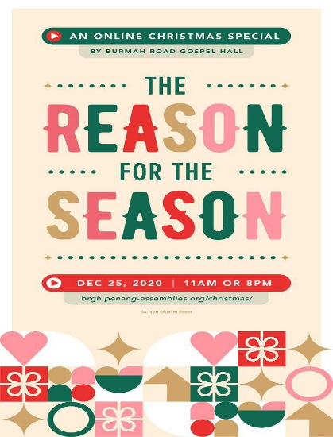
Hence, for this Christmas season, they are holding their Christmas service virtually and anyone can attend this service by visiting it online. This means, whoever you are and wherever you are, you may attend this service without any problem.

Just click on the URL supplied here:
https://brgh.penang-assemblies.org/christmas/
at 11.00a.m. or 8.00p.m. on Christmas Day and you will be there for the service. Not only, can you attend, but also members of your family and your friends all over the world can do so – just synchronise your time with the time of the meeting and you will be there.

See you there and your family and friends. This is the time to reach out to them and enlighten them with the reason for the season. REFLECT

- It is five days more to Christmas.
On that first Christmas night, an angel appeared to the shepherds
and announced to them: Luke 2:10, 11
Fear not: for, behold, I bring you good tidings of great joy,
which shall be to all people.
For unto you is born this day in the city of David a Saviour,
which is Christ the Lord.

For the next Five days to Christmas, will you relay this angel’s message to your Friends and assay their Fear especially at this time of the Covid_19 pandemic and invite them to hear the good news of the true CHRISTmas –
The Reason for the Season? REFLECT.

My family and I take this opportunity to wish you all
An Advanced Blessed CHRISTmas
And A Bountiful New Year

POINTS TO PONDER: Christmas is not X-mas with CHRIST Crossed out –
Put CHRIST back - the Reason for the Season!

