R822 - Rumination for November 1, 2020 by K.C. Ung
The Theme: trees berita-bethel-ung.com
The Text: - And the earth brought forth…the tree yielding fruit…and God saw that it was good. Gen. 1:12
The Thots:
- The Tree in Creation.
- The Sight of Trees in the Garden of Eden.
- Tree occurs First time in the Bible in Gen. 1:11
God said, Let the earth bring forth…the fruit tree yielding fruit after his kind…and it was so.
- With the Fruit trees bearing Fruit after their kind. 1:11
- There were also trees good for Food. Gen. 2:9a
Out of the ground made the LORD God to grow every tree that is pleasant to the sight,
and good for food;

- Two Special Trees in the Garden of Eden.
- …the tree of life also in the midst of the garden. Gen. 2:9b
- and the tree of knowledge of good and evil. Gen. 2:9c
- The Prohibition relating to the Tree: Gen. 2:16, 17
The LORD God commanded the man, saying, Of every tree of the garden thou mayest freely eat:
But of the tree of the knowledge of good and evil, thou shalt not eat of it:
- The Penalty for Trespassing: for in the day that thou eatest thereof thou shalt surely die.
- The “Pleasantness” of the fruit leading to Transgression: Gen. 3:6
When the woman saw that the tree was good for food, and that it was pleasant to the eyes,
…she took of the fruit thereof, and did eat, and gave also unto her husband with her; and he did eat.
- The Problem caused: Behold, the man is become as one of Us, to know good and evil: 3:22
- The Precaution: lest he put forth his hand, and take also of the tree of life, and eat, and live for ever:
- The Punishment. So He drove out the man; and He placed at the east of the garden of Eden Cherubims, and a flaming sword which turned every way, to keep the way of the tree of life. 3:24

- A tree under Curse. Deut. 21:22, 23
- The Criminal: If a man have committed a sin worthy of death, and he be to be put to death, 21:22a
- The Consequence: and thou hang him on a tree: 21:22b
- The Condition: His body shall not remain all night upon the tree,
but thou shalt in any wise bury him that day; 21:23a
- The Curse: (for he that is hanged is accursed of God;) 22:23b
- Compare the Christ Who was Crucified and hung on the Cross for us: Gal. 3:13
Christ hath redeemed us from the curse of the law, being made a curse for us:
for it is written, Cursed is every one that hangeth on a tree:
Note: This Curse was rooted in the Law and the Law could not save us.
Only the Lord Can, because He bore the Curse for us. See #C below

- The Tree, a symbol of the Cross. I Pet. 2:24
- Christ Suffered and died for us on the Tree - Who His own self bare our sins in His own body on the tree,
- Christ was the Sinless dying for the Sinful. I Pet. 2:22
Who did no sin, neither was guile found in His mouth:
- Christ was the Shepherd Who died for the Sheep.
Cp. I am the good Shepherd, and know My sheep, and am known of Mine. Jn. 10:14-15
As the Father knoweth Me, even so know I the Father: and I lay down My life for the sheep.
- The Strayed Sheep is now returned to his Shepherd, the Bishop of his Soul. I Pet. 2:25
For ye were as sheep going astray; but are now returned unto the Shepherd and Bishop of your souls
- The Redeemed Sinner should now live the life of a Righteous Saint I Pet. 2:24
that we, being dead to sins, should live unto righteousness: by whose stripes ye were healed.

- The Tree of Life in the New Creation.
- The Presence of the Tree of Life in Paradise: Rev. 22:2
In the midst of the street of it, and on either side of the river, was there the tree of life…
and the leaves of the tree were for the healing of the nations.

- The Promise to Those worthy to Take of the Tree of Life… Rev. 2:7
- To him that overcometh will I give to eat of the tree of life, which is in the midst of the paradise of God.
- To they that do his commandments, that they may have right to the tree of life… Rev. 22:14
Today we eat of the Bread of Life at the Supper,
Tomorrow we shall eat of the Tree of Life in Paradise!

We may eat of the beautiful tree of life, That stands in the midst of the city so fair;
We may eat of its fruit And be healed with its leaves;
No hunger, no sickness, No sorrow is there. Fanny Crosby

REFLECTIONS FOR THE WEEK R. 822
- The Tree of Life is named four times in Proverbs, the Book of Wisdom. Indeed, it is wise to learn what the Tree of Life is as defined for us metaphorically in this book, though it may have little to do with the original tree of life in Genesis, as follows:
- Proverbs 3:18 – She is a tree of life to them that lay hold upon her:
and happy is every one that retaineth her.
Here wisdom tells us to go after wisdom itself because to have wisdom is to have a long and fruitful life, and in a sense, it is like having the tree of life. In fact,
Happy is the man that findeth wisdom, and the man that getteth understanding. (Pro. 3:13)
This is because wisdom bestows the following:
- Longevity: Length of days is in her right hand Pro. 3:16a
- Prosperity: In her left hand riches and honour Pro. 3:16b
- Tranquility: All her paths are peace" Pro. 3:17
- Which is likened to the Tree: She is a tree of life Pro. 3:18

- Proverbs 11:30
The fruit of the righteous is a tree of life; and he that winneth souls is wise.
Wisdom is when the righteous seeks to win others to be righteous – this then is the fruit of the righteous or to put in other words, the fruit of the tree of life.
A Righteous person begets another righteous one, the fruit of his righteous walk.

- Proverbs 13:12
Hope deferred maketh the heart sick: but when the desire cometh, it is a tree of life.
Wisdom confirms that when hope is fulfilled it comes with all the freshness of the tree of life, that is, when one is diligent to chase after it and to fulfil it. This is in contrast to the sluggard who just hopes or just desires only but does nothing about it. It is therefore nothing surprising to see him get nothing in the end, whereas the soul of the diligent shall be made fat. (Pro. 13:4). For such the desire accomplished is sweet to the soul. (Pro. 13:19)

- Proverbs 15:4
A wholesome tongue is a tree of life: but perverseness therein is a breach in the spirit.
Wisdom tells us that a Wholesome tongue is a Winsome tongue. It brings healing to the listener and freshness to his feelings as a tree of life does to those who taste of its fruit.
It spreads knowledge and understanding - The lips of the wise disperse knowledge: but the heart of the foolish doeth not so. (Pro. 15:7);
By his Words of Wisdom, he disperses much of the joy in him and passes on his happiness to his listeners. It is a word spoken in season and it is good. It is as the freshness of the tree of life – (Pro. 15:23) A man hath joy by the answer of his mouth: and a word spoken in due season, how good is it!

Thus, you need not wait to go to heaven to taste of the fruit of the tree of life. On earth, you can be the tree of life to all others who come into contact with you.
Are you a Tree of Life on Earth? REFLECT.

- These two palm trees are “siblings” planted on the same day – one in a pot (in front of me), the other in the ground. After many years, the potted plant remains short, whereas the one in the ground has grown tall and is bearing much “fruit”. The two plants are like Christians – one growing in the potted confines of his own thinking, the other grounded in the Word of God, growing tall and bearing fruit. Which one are you? REFLECT.
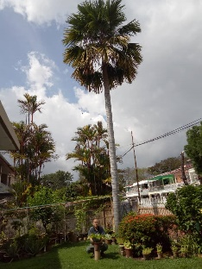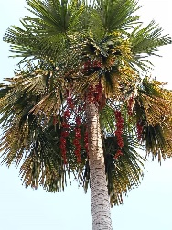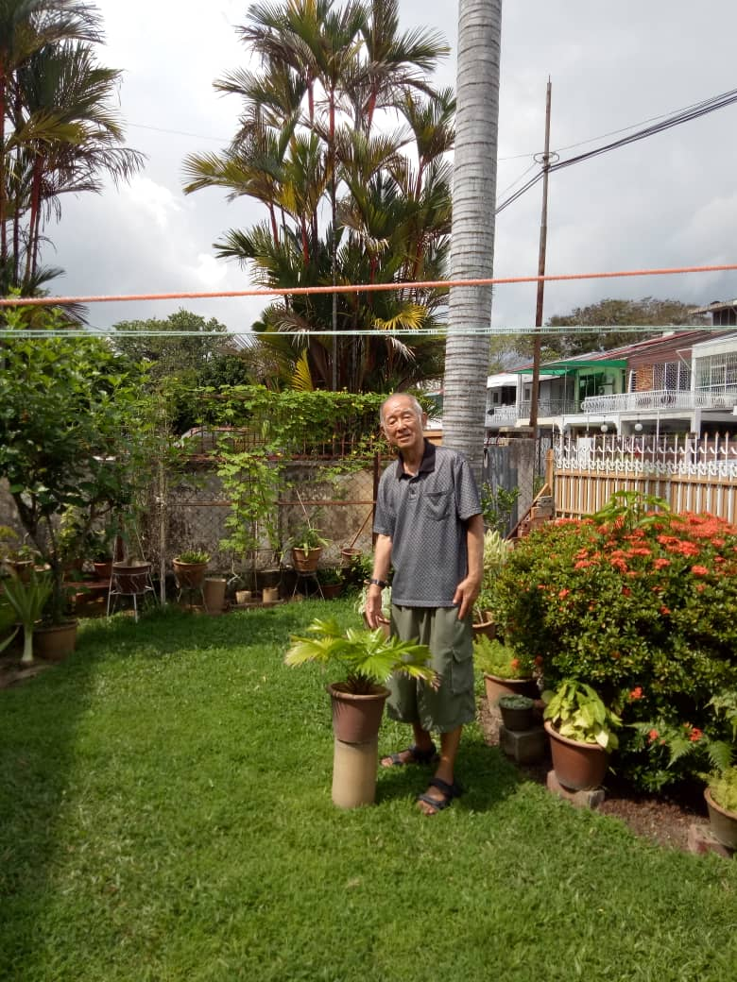
POINTS TO PONDER: A Potted Plant remains Short;
A Tree Planted in the Ground Grows Tall and bears Fruit

