20th Mar., 2022 Sungai Ara Gospel Hall [10.10.21]
Recap.: The Christian Priesthood - Heb. 10:19-25
- The Classes of Priesthood:
[The Levitical Priesthood; The Melchizedek Priesthood]
1. The Original Purpose of God. Exo. 19:5-8
a. The Condition - if ye will obey… cf. 19:8
b. The Covenant & Commandments, Chs. 19-31
c. The Consent sealed by Blood. 24:3-8

Theme: The Christian Priesthood in Hebrews 10:19-25
- The Character of the Christian Priesthood. Heb. 10:19-20
II. The Character of our High Priest. Heb. 10:21
III. The Conditions of the Christian Priesthood. Heb. 10:22
IV. The Commitment of Priests. Heb. 10:23-25
Ye are a chosen generation, a royal priesthood,
an holy nation, a peculiar people. I Pet. 2:9
We are now: A Chosen Generation
- A Peculiar People:
Peculiar: from <G4046> (Peripoieomai) = acquisition (the act or the thing); by extension Preservation :-…Peculiar, Purchased, Possession.
The word translated "peculiar" does not mean strange or eccentric but speaks of a people of possession. That is, God purchased us by Christ paying the ransom for our sins.
Also in the meaning is "preservation" (Thayer). God does not lose His possessions.
Once we belong to God in salvation our souls are safe forever - Butler
- A Holy Nation - A Pure Populace.
- A Royal Priesthood – A Princely Priesthood.

- Pt 4a – The Commitment of Priests
Let us hold fast the Profession of our Faith – Heb. 10:23a
Intro. Christians are Holy Priests to Sacrifice I Pet. 2:5
and Royal Priests to Set Forth … I Pet. 2:9

A. As Holy Priests, we are committed to Sacrifice. I Pet. 2:5 cf. Heb. 10:12
1. OT priests were made such by virtue
of their Birth and their consecration by Blood. Exo. 28, 29
2. Likewise, NT priests, by their new Birth
and their consecration by the Blood of Christ.
3. Their Sacrifices, however are…
not Expiatory (Heb. 10:18), But Eucharistic,
not Based on Rites, But on Redemption. Rom. 3:24, 25

- The Sacrifices of Holy Priests
- The Sacrifice of What I am. Rom. 12:1, 2
a. The Call to Sacrifice.
i. A Real Appeal - I beg of you, please
ii. A Restricted Appeal - brethren, i.e. believers only
iii. A Reasonable Appeal - therefore by the mercies of God

- Let no man despise thy youth, but be thou an example of the believers… I Tim. 4:12
The Young KC Ung: (A Challenge to the young adults)
- At 13, came to know the Lord and was baptised.
- At 13-15, involved in Bible Study classes.
- At 16, involved in open-air evangelism.
- At 17, Supt. Of Taylor Road Sunday School and conducted Children’s Campaign at Cheeseman Road Playground – the foundation of IGGC.
- At 17, with Chang Hon Liong launched the Bible Class at 51 Service Road.
- At 18, first to complete 24 Emmaus Bible Correspondence Courses.
- At 18, with Hon Liong pioneered Butterworth Sunday School, started Bible Class.
- At 20, Supt. Butterworth Sunday School, lay the foundation of English and Chinese-speaking work and later with BRGH, the Butterworth Gospel Hall.
- The Concept of Sacrifice - that you present…
- The Offer – present (cf. Heb. 8:3) Gk. paristemi = to place beside or near, to present, to offer, to put at one’s disposal;
Aorist tense – a once and for all decision
- A Willingness to Sacrifice All we Are: Cf. Lk. 2:22; I Sam. 1:27, 28; Mt. 2:11 - Present
a Levitical term for presenting the victims and offerings.
- A Preparedness to Surrender All we Have.
Present is the same as yield in Rom. 6:13
- A Readiness to Submit all the Way. Heb. 11:8
ii. The Offering - your bodies Cf. I Cor. 3:16, 17; 6:19, 20
- The eyes – to Look on the fields. Jn. 4:35
- The tongue – to Laud the Lord God. Psa. 35:28
- The ear – to Listen to the still small voice. I Sam. 3:10
- The hands – to Lift up in prayer. I Tim. 2:8
- The feet – to Lead others to Christ. Rom. 10:14, 15
- The whole person – to Live for Christ. Gal. 2:20

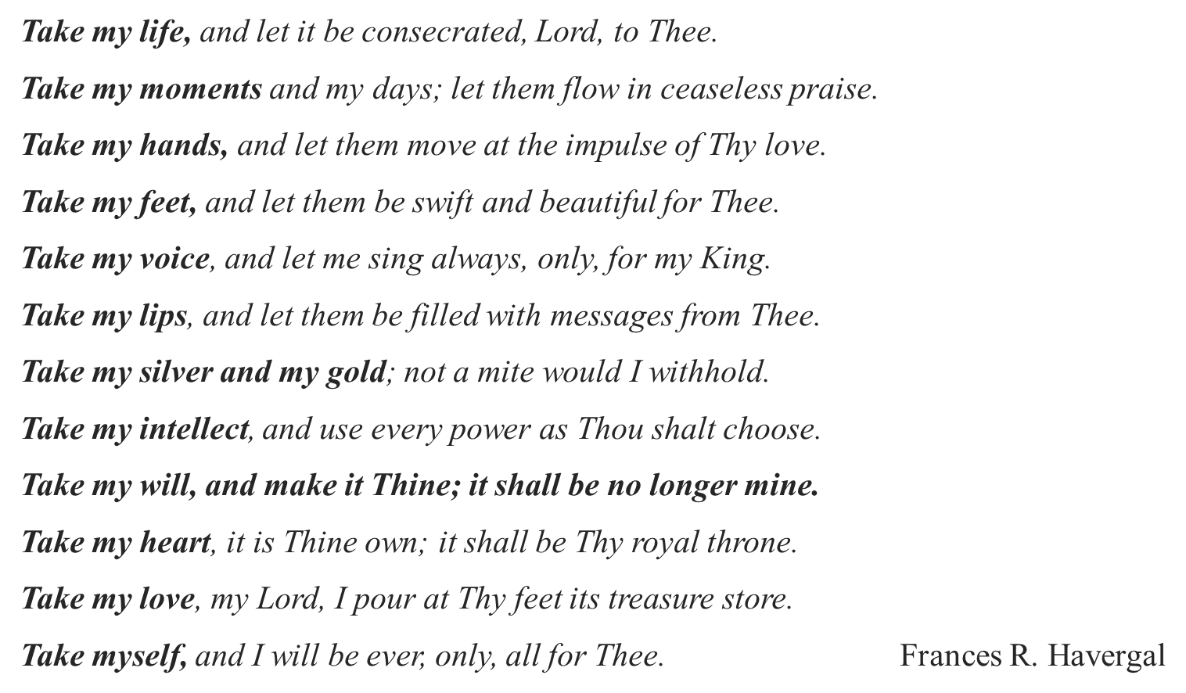

- The Object - a living sacrifice cp. living way;
ct. dead sacrifices of Where the Mind is Alive. Rom. 6:8, 11, 16
- Where the Members are Available. Rom. 6:13, 19
- Where the whole Man is Associated. Gal. 2:20

c. The Conditions of Sacrifices. Holy, acceptable unto God
i. That which is Sacrificed must be Set Apart. Holy
- i.e. Placed at God’s Disposal.
- i.e. Purified of all Defilement.
ii. That which is Sacrificed must be Acceptable.
- It must be Appointed by God. Lev. 1:2ff ct. 10:1, 2
- It must be Approved of God. cf. Acts 2:22; Lk. 2:52

Conclusion: which is your reasonable service
(i) Characterised by Spontaneity. Reasonable
Reasonable (Gk. logikos) = reasonable, agreeable to reason, or the worship that is rendered by the reason or the soul.
(ii) Characterised by Service.
Service (Gk. latreia), i.e. the service or worship of God according to the requirement of the Levitical Law as in Heb. 9:6. Hence, priestly service

Thus, Worship must Precede Service, and Service must Proceed from Worship.

Next Lord’s Day, 27th March, 2022
Pt. 4b – The Commitment of Priests… Heb. 10:23b-25
      - As Holy Priests
      - As Royal Priests. I Pet. 2:5, 9
My Personal Testimony:
My Conversion and Confession.
My Consecration
My Contributions
My Commendation.
Acknowledgement:
Many images in this Presentation are sourced from the Internet with the sole intention of illustrating my biblical teaching
and not used for any profitable purpose.
Note: These images are only illustrations, not necessarily authoritative.
=======================================================================

