22nd Oct. 2017 Sungai Ara Gospel Hall
The “Seven’s” in John’s Revelation

The “Sevens” in John’s Gospel – 20:31; 21:25
The “Sevens” in John’s Revelation – 1:19
22nd Oct. 2017 – Pt. 1: Introduction to the Sevens in Revelation
3rd Dec. 2017 – Pt. 2: Condition in the Seven Churches
10th Dec. 2017 – Pt. 3: The Great Tribulation in the Seven Seal Judgments

Introduction: The Sevens in John’s Gospel:
(1) The Seven Jesus Miraculous Signs
(2) The Seven Jesus “I AM” Statements.

(A) Introduction 1: The Sevens in John’s Revelation:
1. Seven is the number of Completion and Perfection.
2. Seven is a unique feature of Revelation.
a. The Seven’s in Single Occurrences (in KJV).
i. “Seven” (Gk. “hepta”) occurs 87 times in the N. T.
ii. “Seven” occurs 55, and “Seventh” 5, times in Rev.
iii. “Seven”-phrase Occurs 35 (5x7) times in Rev.

b. The Seven’s in Series Outlining Revelation
- The seven-fold Character of Christ - 1:5, 8, 11; 1:13-16 Ch. 1
- The seven Churches - 1:4, 11, 20 Chs. 2-3
- The seven seal judgments - 5:1, 5:5 Chs. 4-6; 8:1
- The seven trumpet judgments - 8:2, 6 Chs. 8, 9; 11:15-19
- The seven bowl/vial judgments - 15:7, 17:1, 21:9 Chs. 15-16
- The seven parentheses Chs. 7, 10-14, 17-19
- The six “thousand” occ. - 20:2-7, ct. 11:2, 3 Ch. 20
- The Seven new Outstanding Subjects Chs. 21, 22

(B) Introduction 2: The Seven Churches in Asia. Rev. 2, 3
- Paul wrote to Seven Churches: Romans to Thessalonians
They Provide the Principles and Practices of the Church.
2. John wrote to Seven Churches in Asia: Ephesus to Laodicea.
They Picture in Prophetic Outline the history of Christendom
from Pentecost to the Parousia of the Church.

(C) Introduction 3: - Revelation in Perspective
- THE PROLOGUE OF THE BOOK.
- The Penman of the Book: John, the Apostle. Rev. 1:1, 2, 4, 9; 22:8
- The Period of the Book: AD. 96
- The Promise of the Book: A three-fold Blessing – read, hear, keep. Rev. 1:3

Seven Beatitudes in Revelation
- 1:3 BLESSED is he that readeth and they that hear…
and keep those things that are written…
- 14:13 BLESSED are the dead who die in the Lord from henceforth… (ct. 14:9-11)
- 16:15 Behold I come as a thief BLESSED is he that watcheth
- 19:9 BLESSED are they who are called unto the marriage supper of the Lamb.
- 20:6 BLESSED and holy is he that hath part in the first resurrection
- 22:7 BLESSED is he that keepeth the sayings of the prophecy of this book.
(wash their robes…, ASV)
- 22:14 BLESSED are they that do His commandments…

II. THE PANORAMA OF THE BOOK.
- The Simple Plan in the Book.
[A Key to Understanding Revelation. Rev. 1:19]
It deals mainly with....
1. The Past - "The things which thou hast seen."
What thou seest write... 1:11 cf. 1:19. Ch. 1
John's Vision of the Exalted Christ,
(the last 7-fold portrait of Christ in the N. T.) 1:13-16

2. The Present - "The things which are" Chs. 2, 3
Outline of the Dispensation of the Church:
  - The Seven golden candlesticks (1:12, 13, 20; 2:1); stars (1:16, 20; 2:1; 3:1); churches (1:20); Spirits of God (3:1); angels (1:20)
a. The Messages to the Seven churches - the Church age. "Write"
- A Contemporary Approach - Past Historical (Preterist)
- A Concurrent Approach - Present Historical (Allegorist)
- A Consecutive Approach - Progressively Historical (Futurist)

b. The Missing (Rapture of the) Church between 3:22 and 4:1.
Cf. occ. of "church/churches" in 3:22; 22:16

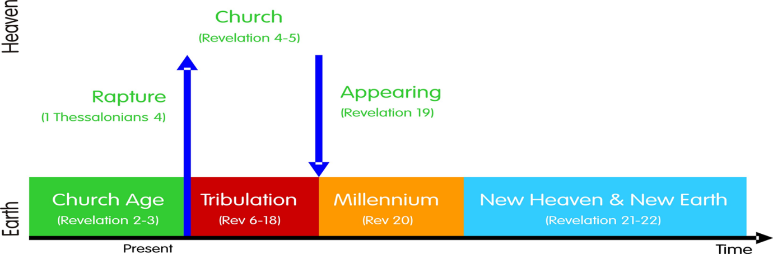

3. The Prospect – "The things which shall be hereafter.” Chs. 4-22
The future after the Rapture of the Church – Chs. 4-5 cf. 4:1
- Their Commencement – "Hereafter", lit. = "after these things", as in 1:19; 4:1, 2
- Their Concentration – The Great Tribulation. Chs. 6-18 (cf. 7:14)
- Their Consummation – “after these things” 19:1 Chs.19-22

B. The “Seven” Parentheses - Figures in the Tribulation. - Chs. 7, 10-14, 17-19

Rev. 12:1-6ff
23rd September, 2017 – Rapture? The Great Tribulation?

Deuteronomy 18:17-20
17 And the LORD said unto me…
18 I will raise them up a Prophet from among their brethren, like unto thee, and will put My words in his mouth; and he shall speak unto them all that I shall command him.
19 And it shall come to pass, that whosoever will not hearken unto My words which he shall speak in My name, I will require it of him.
20 But the prophet, which shall presume to speak a word in My name, which I have not commanded him to speak, or that shall speak in the name of other gods, even that prophet shall die.

Conclusion: Mk. 13:32; I Thes. 5:2; Rev. 3:11

Acknowledgement:
Many images in this Presentation are sourced from the Internet with the sole intention of illustrating my biblical teaching and not used for any profitable purpose.
Note: These images are only illustrations, not necessarily authoritative.

For those interested in…
Viewing the Powerpoint Presentation again;
Listening to the Study again
And/Or Want a full Outline
of the Study,
Please visit (after Tuesday): www.berita-bethel-ung.com

