18th April, 2021 Burmah Road Gospel Hall

Theme: The Christian Priesthood in Hebrews 10:19-25

Recap. : The Christian Priesthood - Heb. 10:19-25

A. The Classes of Priesthood.

1. The Original Purpose of God. Exo. 19:5-8

a. The Condition - if ye will obey… cf. 19:8

b. The Covenant & Commandments, Chs. 19-31

c. The Consent sealed by Blood. 24:3-8

I. The Character of the Christian Priesthood. Heb. 10:18-20
II. The Character of our High Priest. Heb. 10:21
III. The Conditions of the Christian Priesthood. Heb. 10:22

IV. The Commitment of Priests. Heb. 10:23-25

Part 4a - The Commitment of Priests
Intro. Christians are Holy Priests to Sacrifice and Royal Priests to Set Forth … I Pet. 2:5, 9
Ye are a chosen generation, a royal priesthood,
an holy nation, a peculiar people. I Pet. 2:9
The Lord’s Choice of Israel Deut. 7:6-8

My P ersonal Testimony:
Stage 1 – The Lord’s Choice,
my Conversion
and Confession
Stage 2 – My Consecration
Stage 3 – My Contributions
Stage 4 – My Commendation

A. As Holy Priests, we are Committed to Sacrifice. I Pet. 2:5 cf. Heb. 10:12, 18
- OT priests were made such by virtue of their Birth and their consecration by Blood.
- Likewise, NT priests, by their new Birth and their consecration by the Blood of Christ
- Their Sacrifices, however are not Expiatory (Heb. 10:26), bur rather Eucharistic.

The Sacrifices of Holy Priests

1. The Sacrifice of What I am. Rom. 12:1, 2 cf. II Cor. 8:5
- My Personal Testimony
a. The Call to Sacrifice.
i. A Real Appeal - I beg of you, please
ii. A Restricted Appeal - brethren, i.e. believers only
iii. A Reasonable Appeal - therefore by the mercies of God

b. The Concept of Sacrifice.
i. The Offer - present
Gk. paristemi = to place beside or near, to present, to offer, to put at one’s disposal;
Aorist tense – a once and for all decision
- A Willingness to Sacrifice all we Are Cf. Lk. 2:22; I Sam. 1:27, 28; Mt. 2:11
Present is a Levitical term for presenting the Levitical victims and offerings.
- A Preparedness to Surrender all we Have
Present is the same as yield in Rom. 6:13
- A Readiness to Submit all the Way. Heb. 11:8 cf. Psa. 51:17

ii. The Offering - your bodies Cf. I Cor. 3:16, 17; 6:19, 20
- The eyes – to Look on the fields. Jn. 4:35
- The tongue – to Laud the Lord God. Psa. 93:3, 5
- The ear – to Listen to the still small voice. I Sam. 3:10
- The hands – to Lift up in prayer. I Tim. 2:8, 4
- The feet – to Lead others to Christ. Rom. 10:14, 15
- The whole person – to Live for Christ. Gal. 2:20
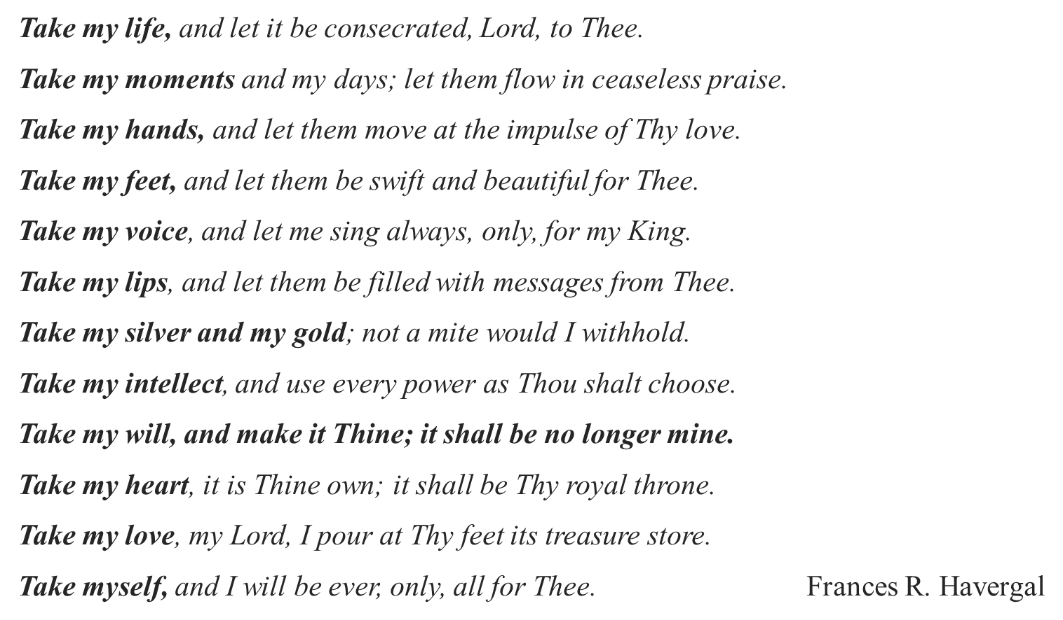

iii. The Object - a living sacrifice cp. living way; ct. dead sacrifices of OT
- Where the Mind is Active. Rom. 6:8, 11, 16
- Where the Members are Available. Rom. 6:13, 19
- Where the whole Man is Associated. Gal. 2:20

c. The Conditions of Sacrifices. Holy, acceptable unto God
i. That which is Sacrificed must be Set Apart. Holy
- i.e. Placed at God’s Disposal.
- i.e. Purified of all Defilement.
ii. That which is Sacrificed must be Acceptable.
- It must be Appointed by God. Lev. 10:1, 2
- It must be Approved of God. cf. Acts 2:22; Lk. 2:52

Conclusion: which is your reasonable service.
(i) Characterised by Spontaneity. Reasonable
Reasonable (Gk. logikos) = reasonable, agreeable to reason, or the worship that is rendered by the reason or the soul.
(ii) Characterised by Service.
Service (Gk. latreia), i.e. the service or worship of God according to the requirement of the Levitical Law as in Heb. 9:6. Hence, priestly service

Service is used of (a) the service of God in connection with the Tabernacle. Rom. 9:4; Heb. 10:1, 6
(b) of the intelligent service of believers in presenting their bodies, a living sacrifice. (Rom. 12:1)
(c) of imagining service to God by persecutors of Christ’s followers, Jn. 16:2 – W.E. Vines
Thus, Worship must Precede Service, and Service must Proceed from Worship.

To be Continued next Lord’s Day.

