For Private Circulation Only. Vol. 30 No. 2 14 Jun. 2026 (from 14 Feb. 2026)
Website: www.berita-bethel-ung.com Email address:beritabethelung@gmail.com ΦΦΦΦΦΦΦΦΦΦΦΦΦΦΦΦΦΦΦΦΦΦΦΦΦΦΦΦΦΦΦΦΦΦΦΦΦΦΦΦΦΦΦΦΦΦΦΦΦΦΦΦΦΦΦΦΦΦ
My Faithful prayer partner/s in the Faith and in the deFence of the Gospel (Phil. 1:5, 7)

The Numbers Eight and Eighty-Eight!
The Number EIGHT Plays a very Prominent and Significant role in Scripture. According to Strong’s Concordance, eight occurs eighty times in the Bible (KJV) and its first occurrence is in relation to God’s Command to Abraham to Circumcise every male Child to Confirm God’s Covenant with him and his Posterity – And he that is eight days old shall be circumcised among you, every man child in your generations, he that is born in the house, or bought with money of any stranger, which is not of thy seed (Gen. 17:12)…And Abraham circumcised his son Isaac being eight days old, as God had commanded him. (Gen. 21:4)

Eight Signifies Something NEW – a new Commencement, a new Cycle, a new Commitment, a new Covenant, a new C…, etc.!!

Thus, God took a Week (Seven days) to Complete His Work of Creation, (Gen 2:2) …
And on the seventh day God ended His work which He had made; and He rested on the seventh day from all His work which He had made.

The Eighth Day would therefore begin a new Week! And in this Context, it may have a reference to the Coming new Creation – And I saw a new heaven and a new earth: for the first heaven and the first earth were passed away; and there was no more sea. (Rev 21:1). And that would begin the Eighth Day of the new Creation, the first time it will be Created.

Why my mention Eight here? Because Eight days ago for the first time, my Brain and my Body were not in sync with the Rotation of the earth, and my world spun all around me, when I turned my head to look left or right while lying down, and my tummy churned round and round on its own axis giving me the feeling of nausea. I also could hardly stand which compelled me later to Grab a cab to consult an ENT specialist at a hospital. I returned home with a pile of medication to get my balance back, though I think my “bank balance” (if I were to spell out) may have a different story to tell!
It was the first time I had an attack of Benign Paroxysmal Positional Vertigo (BPPV) though I had numerous spells of past dizziness due to my hypotension before. Yes, it was a new (“eighth” day) experience that had almost rendered me helpless lying in bed most of the time. My experience was not that bad, as I learned later, that a few more friends had worse encounters than mine.

- Interestingly and significantly, for the next part of my narrative, I would refer to the number of people who were saved from the flood in Noah’s days. It was Eight! as Gen. 7:13 states:
- In the selfsame day entered Noah (1), and (2) Shem, and (3) Ham, and (4) Japheth, the sons of Noah, and Noah’s wife (5), and the three wives (6-8) of his sons with them, into the ark.

At the end of last year, Christmas, 2025, after almost eight (?) years, my eldest son, Christopher and his family returned to his birth place at Bethel from USA with his family for a Family Reunion of 16 (2x8) in our family, with me heading four generations of my wife (1), our children (3) and their spouses (3), our grandchildren and their spouses (5+2) and great grandchildren (2) = 16 (2x eight), not counting the spouse of my newly married granddaughter in US.
Thus the Family Photo of (1 + 2x8) members below:

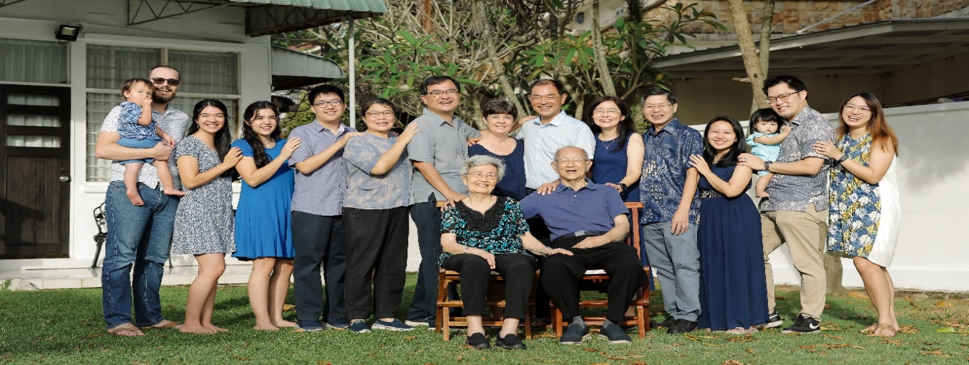

Another significance of the occurrence of Eight in Scripture is that The Feast of Pentecost was to be observed after 49 (Seven weeks) days, (Lev. 23:16 – even unto the morrow after the seventh sabbath shall ye number fifty days (which is the eighth day after 7 weeks) and ye shall offer a new meat offering unto the Lord. Seven days ye shall offer an offering made by fire unto the Lord: on the eighth day shall be an holy convocation unto you; and ye shall offer an offering made by fire unto the Lord: it is a solemn assembly; and ye shall do no servile work therein.
The eighth day was a special day for Israel to Commence a new Cycle for the Congregation to Come together for a Convocation!

Eight also Commemorates the Resurrection of Jesus, for it was on the first day of the week, or the eighth day, that He rose again from the dead – the first day of the week cometh Mary Magdalene early, when it was yet dark, unto the sepulchre, and seeth the stone taken away from the sepulchre. (Jn. 20:1) and it was on the first day of the week (the eighth day) that He appeared to His Disciples: Then the same day at evening, being the first day of the week (the eighth day), when the doors were shut where the disciples were assembled for fear of the Jews, came Jesus and stood in the midst, and saith unto them, Peace be unto you.
Finally, it was on the first day of the week (the eighth day) that the disciples met together to break bread (Acts 20:7).

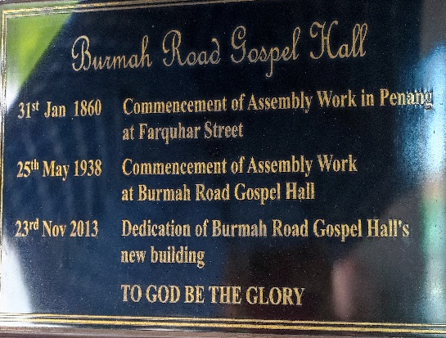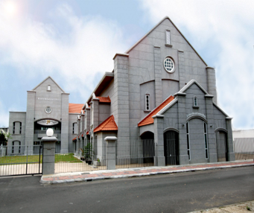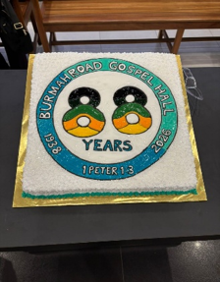

And Sunday, May 24, 2026 was indeed very significant. On this Lord’s Day, and at the Lord’s Supper, the saints at Burmah Road Gospel Hall gathered together on this first day (the eighth day) of the week to celebrate the 88th Anniversary (25th May 1938) of their Assembly Testimony at Burmah Road Gospel Hall [see memorial plague in photo above].
Double Eight also signifies a Double Portion, as Elisha asked of Elijah when the latter was taken up into heaven to be with God – And it came to pass, when they were gone over, that Elijah said unto Elisha, Ask what I shall do for thee, before I be taken away from thee. And Elisha said, I pray thee, let a double portion of thy spirit be upon me. (II Kgs. 2:9) – and may it be so with God’s Bountiful Blessings to be showered on Burmah Road Gospel Hall on their 88th Anniversary – a Double Eight Portion of His Blessings!!

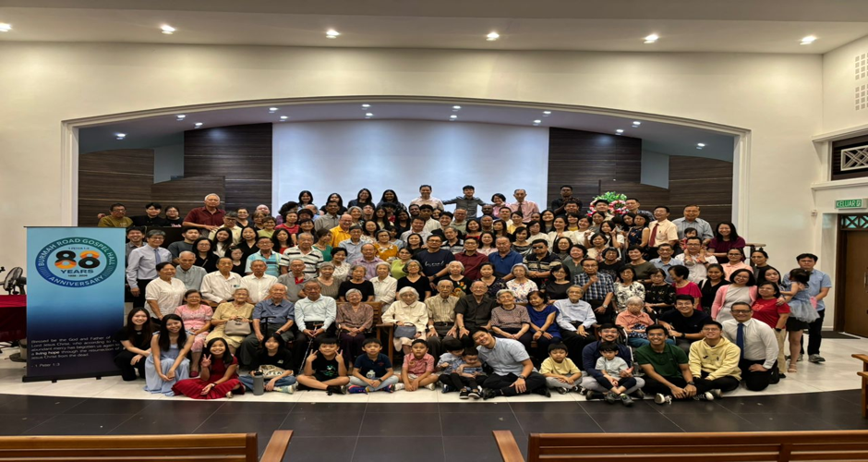

And it is indeed a Double Portion of God’s Blessings as the second part of this portion falls in the same year, as my wife celebrates her 88 years’ birthday anniversary, and also in her association with Burmah Road Gospel Hall about 80 years ago, commencing from her being a Chinese-speaking Sunday School child! Also, there are others in Burmah Road Gospel Hall who are in their eighties and nineties [see photo below] who can claim this double portion of God’s Goodness on their lives too, though they may not have been with BRGH from the beginning to correspond with most of the 88 years of assembly testimony except a few!
To God be the Glory!

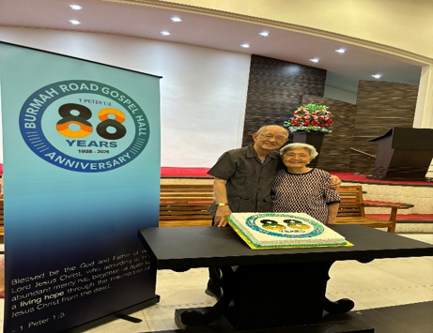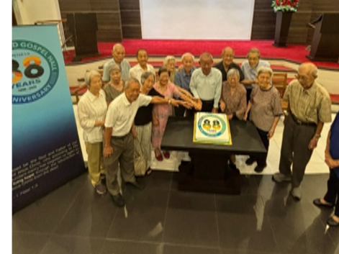

Finally, it may not be Coincidence and it may not be Chance, but perhaps of the Lord’s Choice, that up to this year I have received 8 (eight) invitations to minister God’s Word to the various assemblies, as follows:
- 25 Jan. Jalan Imbi Chapel - Chinese New Year of the Horse.
- 15 Feb. Sungai Ara Gospel Horse - Chinese New Year of the Horse.
- 22 Feb. Burmah Road Gospel Hall - Chinese New Year of the Horse.
- 25 Apr. Burmah Road Gospel Hall - The Christian Hope in I Pet. – Pt. I
- 10 May Sungai Nibong Gospel Hall - Zephaniah – 1:1 – 3:8
- 17 May Sungai Nibong Gospel Hall - Zephaniah – 3:9 – 20
- 26 July Jalan Imbi Chapel - JIC Anniversary (declined, ‘cos committed)
- 23 Aug Burmah Road Gospel Hall - The Christian’s Hope in II Pet. – Pt. II.
In Conclusion, my wife and I would like to thank again all our-fellow Prayer Partners for Praying for us, and for their spiritual and Practical Partnership with us all these years. Thank you and may the Lord’s Presence and Promises be always your Portion as they Double up with His Provision, Protection and Prosperity, Amen!

To God be the Glory!
And A Double Eight Blessing to all Dads, Grandads and Great Granddads
on this Father’s Day
The Lord Bless You All.

