For Private Circulation Only. Vol. 30 No. 1 14 Feb. 2026 (from 01 June, 2025)
Website: www.berita-bethel-ung.com Email address:beritabethelung@gmail.com ΦΦΦΦΦΦΦΦΦΦΦΦΦΦΦΦΦΦΦΦΦΦΦΦΦΦΦΦΦΦΦΦΦΦΦΦΦΦΦΦΦΦΦΦΦΦΦΦΦΦΦΦΦΦΦΦΦΦ
My Faithful prayer partner/s in the Faith and in the deFence of the Gospel (Phil. 1:5, 7)

Two are better than one; because they have a good reward for their labour.
For if they fall, the one will lift up his fellow: but woe to him that is alone when he falleth;
for he hath not another to help him up. Eccles 4:9, 10
1 + 1 = 1 or 2 or 3?!
Very often events or incidents do not come or occur one at a time. They come for good, or even, for bad one after another to the happiness or despondency of the one experiencing them. And such were my experiences during the last term since I last wrote.

Was I happy when I scraped the side of my car at the gate of Burmah Road Gospel Hall as I turned outwards to go on to the road? It hurt to see those scratches indented on the car door and then to have them filled in and repainted at a high cost. But 1 + 1 must = 2, so declares the natural law of accidents; and so, this whole scene was repeated in exactly the same way with similar results just last month!

Oh, so declared a few concerned and opionated friends: this must be the result of my age 8 + 8 (oh, do not add them up to a sweet sixteen for I have gone past it long, long time ago – just stand them up side by side!) years old. I should no more be driving when in certain countries septuagenarians are already not allowed to sit behind the steering wheel! In the end, it cost me nearly RM900.00 to have the car look like new again in total. Sigh.

Yes, at that age (+ 1) now, I also should no longer go for my morning walks alone at Gurney Bay in the dark hours of the morning dawn. Last year I tripped and fell headlong to bruise my face on the road surface, and last month to complete the 1 + 1 equation, I tripped over the Pavement at Gurney Drive and fell into the side drain again. And there was no one to lift me up. But in both cases the Lord was there, and there was no external bleeding as then it would have been risky as I am on blood thinners.

So, while 1+1 = 3 (with the Lord as the Third Friend standing by) to lift His child up on both occasions when there was no one walking by to render a helping hand, the occasion could be bitter, it was for the better too! I learned to be careful now!

This term, my wife and I were blessed with other better blessings as well. We were blessed with 1 + 1 great-grandchildren for the first time – Shiloh from Mark and Tara, daughter of Christopher and Deborah, and Sheryl from Alicia and Daniel, son of Dorothy and Robert. And here they are greeting you all… A BLESSED AND PROSPEROUS CHINESE NEW YEAR!

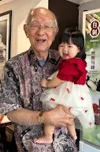
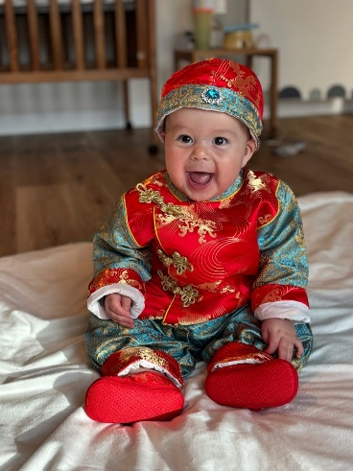
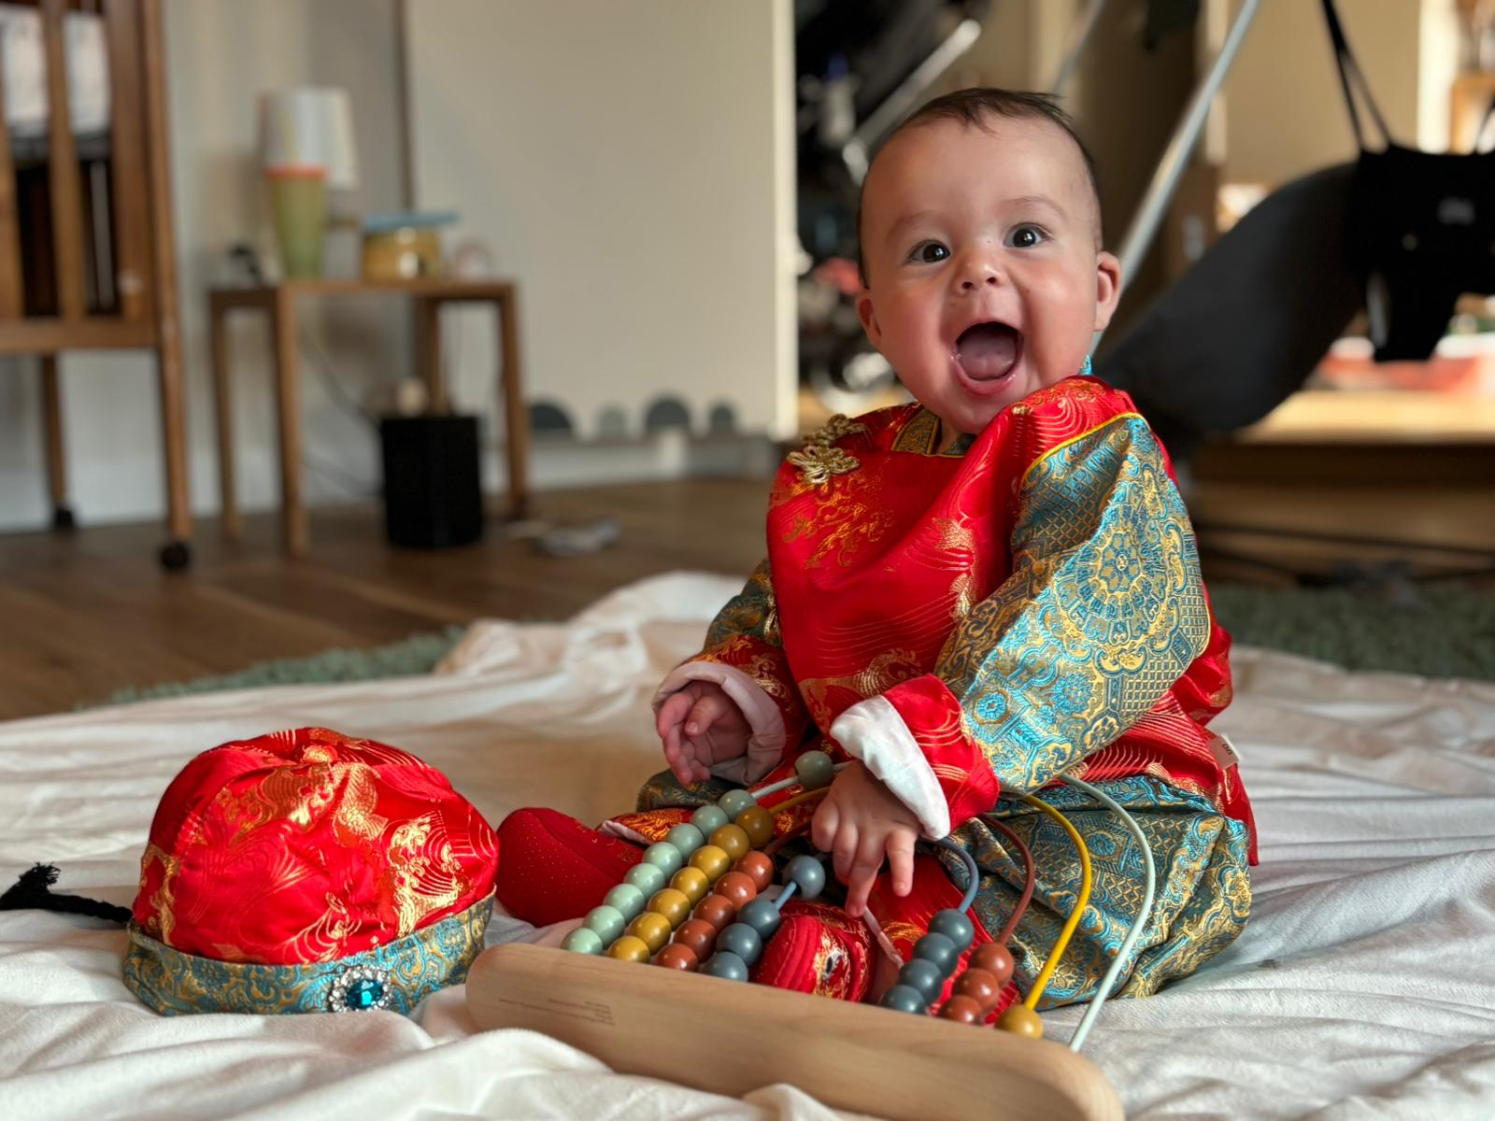

1 + 1 can also point to our granddaughter Hannah married to Vincent last month. In their case it is 1 + 1 = 1 as the two have become one flesh. Yes, the Ung-Khaw clan has indeed enlarged,
In Remembrance of their marriage, I wrote a special Reflection in my weekly Rumination to Remind them of their Relationship and Responsibility of 1 + 1 = 1, Referring to the Marriage Symbols of their Ring, Kiss and Veil that they displayed, enacted and were witnessed to by the guests who were there.

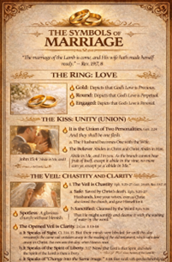
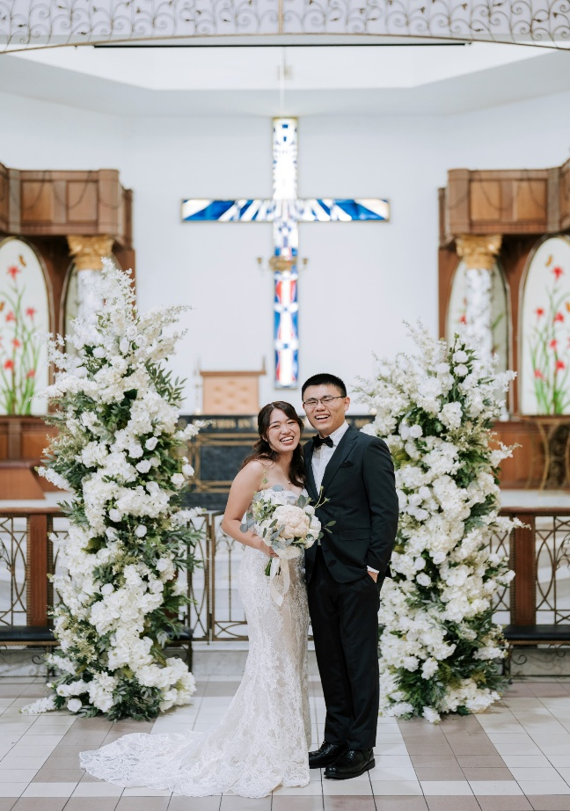

Those who are interested in the Rumination above can click on this URL:
https://www.berita-bethel-ung.com/ruminations/2026/1095rumination25jan2026.docx

In Response to the above Reflection, Hannah’s Dad, Robert wrote, as he Remembered his mum-in-law’s Recipe for her famous Laksa so fondly enjoyed by all then in his WhatsApp Reply to me:…

[14:00, 27/01/2026] khaw Robert: My Rejoinder to Patriarch’s “The Symbols of Marriage” in his Rumination 1095 … and especially for newly-weds HnV, and also all married couples in the family, and those aspiring the gift of marriage one fine day!
Marriage is like Ah Mah and Mom’s famous Penang laksa, requiring many and various ingredients to create a sour and savory broth, namely, bunga kantan (ginger flower), daun kesum, asam keping (tamarind peel), asam jawa (tamarind paste), lengkuas, serai (lemon grass), galangal, tumeric, ginger, shallots, mint leaves, red chilies, dried chillies, onions, shredded lettuce, belacan, heh koh (shrimp paste), salt, sugar, lime juice, pineapple chunks, cucumber, water, ikan kembong (mackerel or sardines), and of course laksa noodles.

Similarly, marriage requires praying alone and praying together; nurturing and encouraging each other to in-take God’s Word regularly; practising a love that chooses boundary - that chooses to daily love each other - that chooses a shared faith in God; submission; respect; faithfulness; forgiveness; sacrifice; mutual understanding; helping and caring for each other; selflessness; no self-insistence on one’s own way; tons of patience; neither being rude nor arrogant; practising letting go of bitterness or resentment; listening well; willingness to consider the other’s interests in decision-making; willingness to agree and disagree agreeably (WADA); safeguarding one another, doing certain things together while at the same time encouraging the other partner to pursue his/her unique interests and grow in the Lord; enjoying wholesome fun; being able to laugh (including laughing at one’s silliness!), rather than being highly intense (intensifying others!); being hospitable toward others; being wholly (not partially) committed to the Lord, family, church; and reach out together for their Lord Jesus’ sake.

It is my hope that my Rumination and Reflection, and Robert’s Reminder from his mum-in-law’s Recipe, will ever be a 1 + 1 = 1 Rejoinder to all of us too of Hannah’s and Vicent’s Marriage Vows that they took before God and before Man.

I thank the Lord too that last month because my wife and I were at Hannah’s wedding, we were both in KL. Consequently, I took the opportunity to speak in their “open” meeting at Jalan Imbi Chapel ushering in the Chinese New Year of the Horse in advance. Next week it will be another 1 + 1 = 2 when I speak on the same topic at Sungai Ara Gospel Hall and Burmah Road Gospel Hall the week after.

This year the Ung patriarch and matriarch have 1 + 1 family reunions.
They commenced last December when Christopher brought his whole family of wife, daughter and son-in-law, Isabel and Shiloh all the way from Florida to join their counterparts in Kuala Lumpur to meet at a Air BnB Bungalow at Jalan Abbas, and at Bethel for a family reunion. All members in the Ung and Khaw clans were present for the first time.

There will be a (1 + 1)nd time this year when all will meet again at Bethel with two parties in Florida and Texas respectively joining those from KL to meet via zoom at Bethel. This 1 (Family Reunion) + 1 (Chinese New Year) = 1 Family reunion will indeed be very memorable as Shiloh, Vincent and Sheryl join us for the first time.
Now my wife and I, and our Clans take this opportunity to wish you all
A (1+1) BLESSED BOUNTIFUL AND PROSPEROUS
CHINESE NEW YEAR.

