For Private Circulation Only. Vol. 29 No. 2 (01 June, 2025 from 20 February, 2025)
Website: www.berita-bethel-ung.com Email address:beritabethelung@gmail.com ΦΦΦΦΦΦΦΦΦΦΦΦΦΦΦΦΦΦΦΦΦΦΦΦΦΦΦΦΦΦΦΦΦΦΦΦΦΦΦΦΦΦΦΦΦΦΦΦΦΦΦΦΦΦΦΦΦΦ
My Faithful prayer partner/s in the Faith and in the deFence of the Gospel (Phil. 1:5, 7)
[First, my Apologies to All Concerned for missing out on my Weekly Ruminations
for the last two Weeks. The Reason is as Follows:]

Do you Believe in Angels? ... Do you Believe in Miracles? ... I Do!

- Introduction: Angelic Announcements of the Miracle of Childbirth…
Lk. 2:10, 11 And the angel said unto them, Fear not: for, behold, I bring you good tidings of great joy, which shall be to all people. For unto you is born this day in the city of David a Saviour, which is Christ the Lord.
Matt. 18:10 Take heed that ye despise not one of these little ones; for I say unto you, That in heaven their angels do always behold the face of My Father which is in heaven.
The Miracle of Childbirth: A Fusion TWO Hearts, TWO Hopes, TWO Heritages entwined to bring ONE new life – the mysterious union of Love and Life, of Strength and Surrender…
A Divine Design written in the Secret places – where the Unseen becomes Seen; and the invisible takes Breath. It is not Biology, but a Sacred Choreography of Body and Soul, of Pain and Promise of the Celestial touching the Terrestrial.
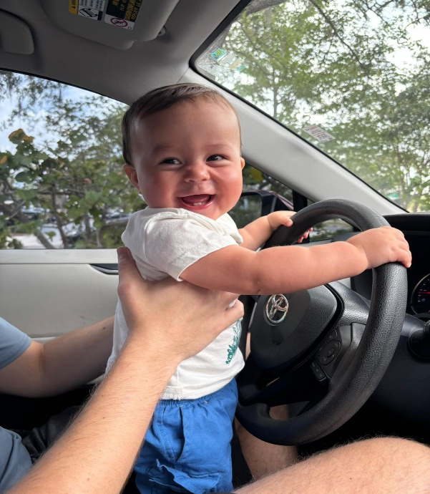
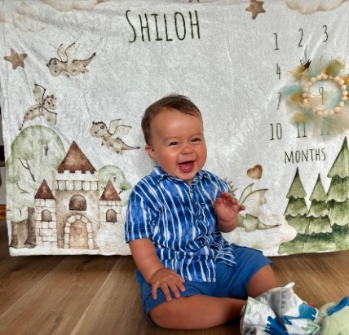
Thus, on 29th July 2024 (US time; 30th July, Malaysian time) An Angel in Florida, America, Announced the Birth of Shiloh Athanasius Harrison to Mark and Tara Harrison, thus, bequeathing my wife and I, the new rank of being Great Grandparents, and Christopher Ung and his wife, Deborah, as Grandparents for the first time.

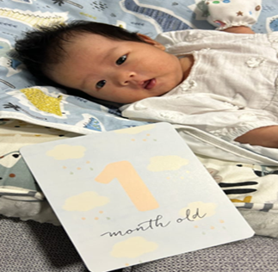
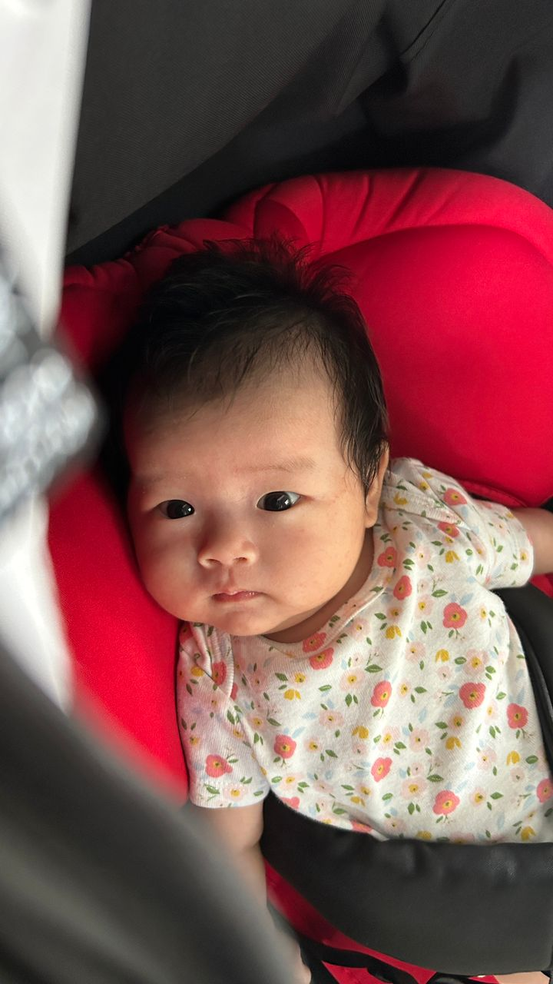
Then Again Another Angel Announced the Birth of SHERYL KHAW ZHI LING to her parents, Daniel Khaw and Alicia Low, thus, in turn, bestowing upon my wife and me the second time, the rank of great-grandparents in our family and our daughter, Dorothy and her husband, Robert Khaw the rank of Grandparents for the first time on 17th April, 2025

- Instances of Promised Angelic Assistance in their Ministry to God’s People:
- Psa. 91:11, 12 - For He shall give His angels charge over thee. To keep thee in all thy ways.
They shall bear thee up in their hands; lest thou dash thy foot against a stone.
- Exo. 23:30 - “See I am sending an angel ahead of you to guard you along the way and to bring
you to the place I have prepared.”
- Heb. 1:14 - Are they not all ministering spirits, sent forth to minister for them who shall
be heirs of salvation?
- Incidents of God’s Angelic Manifestations in Persons Dear to us:
14 May @ 13.13 – Gleneagles Hospital ambulance transported me to hospital under emergency
conditions when suddenly, earlier I found myself not being able sit up in bed at home. My legs were without strength. My wife could not lift me up either.
Hence, she sent for an ambulance.
@14.21- In the emergency ward, I had high fever and underwent tests. I had Covid!
@ 16.31- Quarantined in isolation ward.
@ 23.23 - Then God sent His Angels to Assist:
Angel 1: A brother (from Tanjung Bungah) on being informed that I was warded in hospital brought me some personal effects for stay in hospital.
15 May @ 9.40 Covid symptoms started to manifest. Wife was advised to take Covid test at home.
@16.43 Angel 1 dropped by to help wife to take Covid test. The result was negative.
16 May @ 13.23 Angel 2 – Wife reported that a couple from Bayan Lepas very kindly delivered tok-tok mee and pastry to her for lunch knowing that she was now alone in the house and unable to prepare food at home or to go out to buy any.
@ 14.00 Angel 1 brought over some food specially cooked by his mother (Angel 3) for my wife.
17 May@ 9.15 Wife reported that she did not sleep well the night before, had running nose and
felt tired. Wife faced movement problems. She had no one to take her to see the doctor.
@ 10.07 Angel 4– A couple from Sungai Nibong dropped in to give wife food and fruit
that would last her a few days to sustain her when she’s alone, with me in hospital.
@ 11.14 Wife again tested herself for Covid and still negative.
@ 15.56 In hospital, I felt much better now; could get up and take a few small steps with
nurses’ assistance.
@ 20.22 Angel 5 – The day before (with me warded in hospital and wife alone at home) I had requested a sister from Balik Pulau who had volunteered to help me water the plants in my garden to do so, which she lovingly did yesterday. However today she phoned me to say she would go back to water my aloe vera plants as she forgot to water them then. Did she forget or God made her forget so that…
@ 20.25 When she called for my wife to open the gate, there was no response. So, she contacted me and I texted my wife who then greeted her at the door. She asked her to take her to a clinic as she was feeling very unwell. But all clinics were closed as it was Saturday night. As they passed by Gleaneagles, she asked the angel to take her to the Emergency Ward. She was immediately tested and found that she was Covid positive. Angel 5 was kind enough to wait until my wife was admitted before she left for home in Balik Pulau past 10p.m. She was indeed an angel sent by God to forget to water my aloe vera plants so that she had to go back to my home the day after just to water them. It was then that she found my wife alone in need of help to go for a medical checkup.!!!
@ 22.26 Angel 6 was my daughter, though busy with her newly-born granddaughter in KL left home to come to Bethel to take care of both her parents (two more babies?) who were warded in hospital.
18 May @ 7.30 Yes, confirmed, wife warded for Covid in the next room in isolation ward.
@ 9.33 Later the two of us were moved to a regular isolation ward for us to be together.
@ 14.50 Angel 6 arrived at Bethel and would stay here to care for her parents in hospital.
19 May – Stay in Hospital - undergoing tests and given medical treatment. Would have to stay there for more than a week.
20 May - Maid supposed to come to Bethel to clean up the house. But failed to do so.
Angel 1 met Angel 6 and she asked him for advice to sanitize Bethel. He could help as he had a fogging machine, otherwise she would have to use a small Dettol canister!! This was to ensure that the house was safe for her to stay in.
23 May - 13.30 I was discharged from hospital.
Back at home sweet home with a lot of follow-up medication.
25 May - 13.30 My wife was discharged and we are now back home safe, and hopefully safe and sound.
26 May - Angel 5 stayed with us to lovingly care for and run errands for us. A few other angels came to minister food to us as the angel did for Elijah (I Kgs. 19:5)
And as he lay and slept under a juniper tree, behold, then an angel touched him, and said unto him, Arise and eat

Summary Stay at Home after Hospitalisation
We are thankful to the members of our family who sacrificed the presence and help of their loved ones to care for us when we were down with COVID:
Dorothy, our daughter, came all the way from Kuala Lumpur to stay with us from 18th May to 1st June to care for us at Bethel. Alvin Ung, our son, who came (with his family) on June 1st had suddenly to return home to KL the next day because, he in turn, was tested positive for Covid, probably infected when he was in Singapore a few days earlier before coming to Penang.

We are thankful to our grandchildren (Daniel and Alicia) who sacrificed their mother, Dorothy, who had agreed to help care for their new-born child earlier but now had to care for their grandparents instead, and also to her husband and daughter who missed Dorothy’s help and presence.

Lastly, we are thankful to Christopher that in spite of having to see to his business in China yet had time for us as we updated him from time to time concerning our condition with his family praying for us too.

All in all, we are grateful to the many angels sent by God from near and far to minister to our needs in such a miraculous way to care and provide for us, especially when my wife was alone. Angel 7 from near Pulau Tikus also dropped in now and again to attend to our needs when she sensed we needed it. For all of you out there, thank you for your prayer and concern extended to us in time of need, and even after we had been discharged from hospital to visit and to check on us. This was indeed quite an experience my wife and I had with God, experiencing His miraculous and timely protection, provision and personal presence in such a real way with the care of the angelic ministry of His People as well.
Thank you, Prayer-Partners and the Lord bless you all.

Do I believe in Angels? Yes, I do.
Do I believe in Miracles? Yes, I do.

To God be all Glory and to all His Angels who minister to my wife and me
when we were in Hospital, and after that, at Home. THANK YOU AND GOD BLESS.

There are some things I may not know, There are some places I can't go,
But I am sure of this one thing That God is real for I can feel Him deep within.
Refrain:
Yes, God is real, real in my soul, Yes, God is real for He has washed and made me whole;
His love for me is like pure gold, Yes, God is real for I can feel Him in my soul.

Some folks may doubt, some folks may scorn, All can desert and leave me alone,
But as for me I'll take God's part For God is real and I can feel Him in my heart.
[Refrain]
I cannot tell just how you felt When Jesus took your sins away,
But since that day, yes, since that hour God has been real for I can feel His holy pow'r.
[Refrain]
Source: The A.M.E. Zion Hymnal: official hymnal of the African Methodist Episcopal Zion Church #53

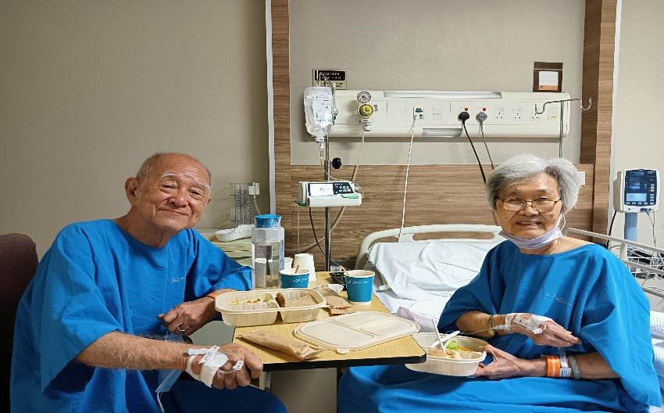
Emmanuel! Ebenezer!

