Berita Bethel

of K.C. UNG

For Private Circulation Only Vol. 11 No. 3 (October 2007 from July. 2007)
ΦΦΦΦΦΦΦΦΦΦΦΦΦΦΦΦΦΦΦΦΦΦΦΦΦΦΦΦΦΦΦΦΦΦΦΦΦΦΦΦΦΦΦΦΦΦΦΦΦΦΦΦΦΦΦΦΦΦΦΦΦΦΦΦ
My Faithful prayer partner/s in the Faith and in the defence of the Gospel (Phil. 1:5, 7)

ΦΦΦΦΦΦΦΦΦΦΦΦΦΦΦΦΦΦΦΦΦΦΦΦΦΦΦΦΦΦΦΦΦΦΦΦΦΦΦΦΦΦΦΦΦΦΦΦΦΦΦΦΦΦΦΦΦΦΦΦΦΦΦ (Psa 118:24 KJV) This is the day which the LORD hath made; we will rejoice and be glad in it.
This was the Day…
…Of my Annual visit to Kepong and SD.
The day was 21 Sept. stretching over to 23, and I rejoiced in it to see the almost-filled Kepong Gospel Chapel (KGC) assembly hall with believers who turned up every night to listen to a series of studies on Typology entitled Pictures in the Pentateuch. I was greatly encouraged to see the keen interest of the saints engrossed in the two-to-three-hour studies each night.
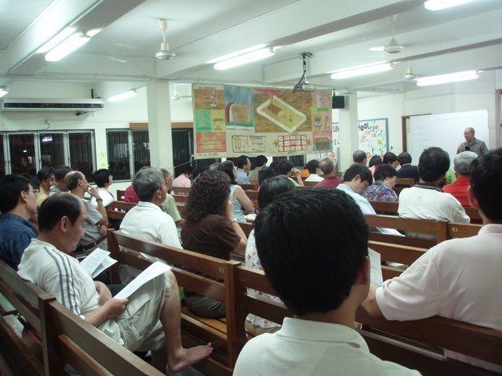

The day was 23 Sept. and I rejoiced for the opportunity to speak on The Year of the Pig at the request of Sri Damansara Gospel Centre (SDGC) on that Lord’s Day morning in their new assembly hall. Much of the inside of the three-storey building (top floor rented out) was self-painted and self-constructed by the local believers. I really rejoiced to see such a good spirit of cooperation, and thankful also to Lim Yau Chuan and his wife, Leonie, who so graciously and generously hosted my wife and I in their home for the whole period. Pictures of my ministry in KGC and SDGC are posted on my website. See URL above.
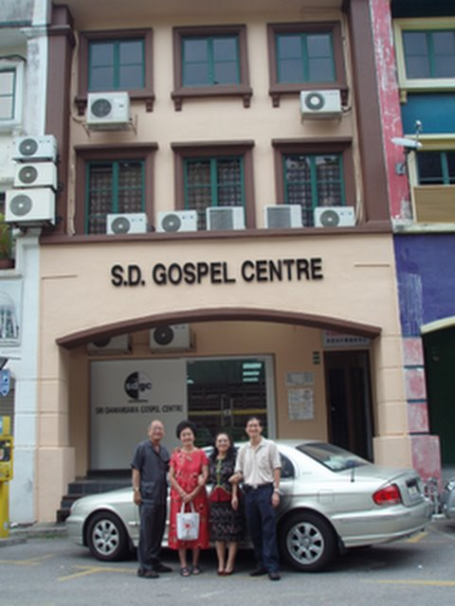
Annual Visit? I go to KGC/SDGC practically every year and they have already invited me back on October 17-19, 2008 (DV).

..Of our AirAsia Holiday
July was my rest month. And the days were from 22-27 when my wife and I together with my cousin, Eng Lay and his wife, Lily rejoiced for the opportunity to go
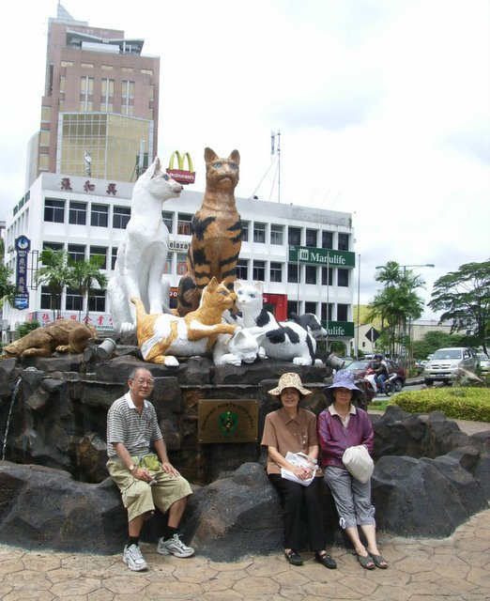

for a holiday to Kuching, having been successful in booking AirAsia tickets to fly us there at zero fare. This was our second time to Kuching and Damar Laut. We rejoiced for “this day” that the Lord had provided for us to have a good rest after six months of a tight speaking schedule for me. The last three months were especially heavy and I was thankful for the respite.

…Of my Attendance at the ALC
The days were from 19-21 August. I rejoiced at the Lord’s provision of two couples’ concern that I should attend the Malaysian Assembly Leaders’ Conference (ALC) at Genting View Resort, Genting Highlands. Their practical concern provided the means and transport for me to do so, as I was invited by ALC to take one morning devotion at the three-day Conference. The theme of the Conference was “Assembly Growth – Building Together” and I spoke on “Building and Growing Together”. It was a good time to renew friendship, re-establish fellowship and rejoice together in the Lord.

…Of our Accident
Saturday, 29 September was one day my wife and I would like to forget and remember, and yet, through it all, we can still rejoice together.

We had gone for our morning walk at Gurney Drive. Then we decided to go to Jelutong, six miles away, to do our marketing. As we were about to turn into the lane leading to the market, the front wheel of my motor-cycle slipped into a groove in the unevenly repaired main road, and back-wheeled. This forced the vehicle to unload its two riders. While it pinned my right leg down to the road, it also banged my wife’s legs hard on one knee. Somehow we survived the fall and rode home after a couple of passers-by helped us up. We thanked the Lord for His protection.
On arriving home, my wife’s blue-black, tennis-ball- sized-swollen knee drew concern, and we visited a 24-hour clinic at once. The doctor on duty advised her to go to the hospital emergency ward immediately.

At the Loh Guan Lye Specialists’ Hospital, we had to send for an on-call orthopaedic surgeon, who, on seeing her condition sent her for an x-ray, admitted her, and scheduled her for an operation on Monday. The reason for her swollen knee was the presence of blood clots which were removed through surgery. A sample was shown to us – they looked like raspberry jam! She was hospitalised and confined in bed for almost one week for her to recover.

We take this opportunity to thank all loving fellow-saints who visited her, prayed for her, loaded her with fruits and food, and even continued to do so after she came home as they knew I was in no position to cook for her nourishing herbal food and other preparations to help her recover fast. To these loving brothers and sisters in the Lord, we would like to say a big Thank You. Though much recovered, she still has to go for her twice-weekly physiotherapy until end of November.

As a consequence of this accident, three matters come to mind: (1) the advice by almost all who heard of the accident for me to throw away my 1970 PK9454 Honda 70 motor-cycle junk and to use my 1986 PBE2050 Toyota Corolla instead. (2) Mrs. Lim from SDGC with whom we stayed (see above) reported our accident to her cell group to pray for us. On coming home, while walking to her door, she tripped and fell flat on her face, injuring it, her arms and legs. (3) When my wife and I were in Sydney, we stayed with an elderly missionary couple. We noticed that this godly servant of the Lord never drove out in his car without first breathing a prayer to the Lord for His protection.

I shall leave it to you to puzzle out the moral of what I am trying to say above.

This is one day, we would like to forget or remember, but we will rejoice in it as we thank Him for showing us evidence of His personal protection, and the loving provision through His saints.

…Of Anniversaries
This is the day of Anniversaries:-
October 20 was the 11th Anniversary of my commendation by Burmah Road Gospel Hall to a teaching ministry in Malaysia and Singapore but which has taken me far beyond these two countries.
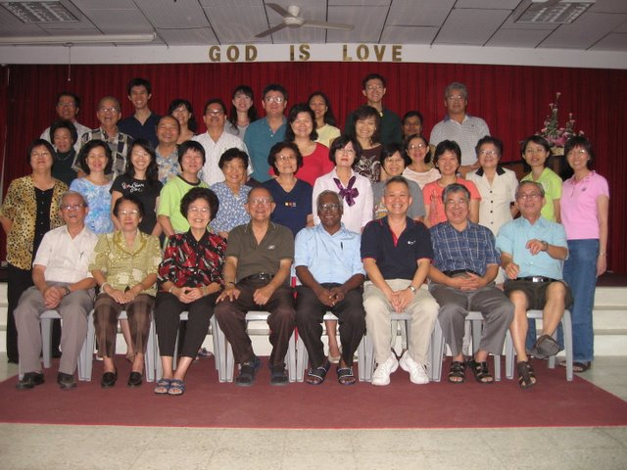

I am very grateful to a loving Christian couple in Penang who remembered me for this special date. I am grateful too for another anonymous believer/couple from Bethesda Ang Mo Kio-Depot Walk for having fellowship with me on this day though they did not know it. Likewise two other couples from an assembly in Penang. I believe that this was the day the Lord had made for me to rejoice in Him in His kind and timely provision in moving the hearts of these loving saints to remind me that the Lord God IS Good and Great and He is ever faithful to His own. Others may forget, but He does not.
October 28 was the 10th Anniversary of Mission Night and The ECHOS. This is the Milestone in the history of my commended service for the Lord. The Mission Night and The ECHOS are the two Monuments erected as Memorials in my Ministry for the Lord these eleven years. It was the day the Lord had made, and I would rejoice in it.

What is significant about these two events?

The first Mission Night testified to the first Anniversary of my Commendation on 20th Oct. It was held on 15th Oct. It was to take the place of a poorly attended prayer meeting in my assembly and to create mission awareness among the assembly believers in Penang. Today, the bimonthly Mission Night is attended by representatives from all assemblies in Penang. It has provided opportunities for local believers to be personally acquainted with assembly missionaries and missions in Australia, Cambodia, China, England, India, Indonesia, Malaysia, Myanmar, Kazakhstan, Pakistan, Philippines, Singapore, etc.

The ECHOS, a mission prayer bulletin, distributed on Mission Night provides regular intercessory coverage for the Lord’s labourers and work in the above countries as well as Afghanistan, Laos, Middle-east, Mekong River Basin, New Zealand, Sri Lanka, Vietnam, etc.
(For the History of Mission Night and The ECHOS visit my website at www.berita-bethel-ung-com. )

This mission project held a 10th Anniversary Thanksgiving Service at Sungei Nibong Gospel Hall (in place of Burmah Road Gospel Hall which is undergoing renovation) on 28th October. In conjunction with that a Mission Seminar was conducted by Loh Ah Asiau, (1st Mission Night guest speaker). With this, I also stepped down as Chairman of the Mission Committee, with Kenneth Oh, stepping in. I now function as Adviser, being very happy that over the ten years the “Timothy’s” have been put in place. This is the Day the Lord has made, and I rejoice in it.

…Of the Assembly Bible Class
October 21 was the day when the Assembly Bible Class sponsored by Sungei Nibong Gospel Hall (SNGH) ended its two-year study of Tim La Haye’s book, “Understanding Bible Prophecy” with a fellowship dinner. The class is another milestone in my service for the Lord as every 1st and 3rd Sunday the 30 over participants from the assemblies on the island and mainland of Penang meet to study God’s Word. For this I have the Oversight of SNGH to thank. Their vision and mission to provide opportunities to the saints in Penang who want to study the deeper things of God, preparing them for leadership, their commitment to help these believers, and their sacrifice to provide the facilities are indeed exemplary. Even as we held our last study together on the Judgment at The Great White Throne, it was a day the Lord had made for us to gather thus, and certainly we would rejoice it in. I understand that they would want me to continue next year (DV). Note: this Class first started on 22nd April,
2001. I am thankful to the Lord for the faithful “students” who faithfully attended the class all these years.

The Day for the next Appointment
My next appointment is to travel to Kuala Lumpur on 6 Nov. with my wife for our nephew’s wedding, and taking advantage of this to see Alvin and Huey Fern, Dorothy and Robert and their children at the same time. We should be back at Bethel on the 10th.

From 16 – 18 November, we shall be at Elim Gospel Hall, Ipoh where I shall speak on their two-year (2007 and 2008) assembly theme: What Does It Cost Me…?
based on selected studies from the book of Malachi.
December will be my rest month. As the Lord leads and as the Lord provides, we shall just leave it to Him to lead us where He wants us to go and to do what He wants us to do.

In the meanwhile, we know that December is going to be a very busy month for all assemblies generally as they make preparations for Christmas, end-of-year meetings and welcoming in the New Year.

Therefore, my wife and I take this opportunity to thank all of you for your loving prayer fellowship, generous practical partnership in my ministry for the Lord among His people and to wish all of you the Lord’s most abundant blessings for …

A Meaningful Christmas and
A Blessed New Year
In the Lord

-------------------------------------------------------------------------------------------------------------------------------------------
Page of Praise and Prayer Points
The following table gives an idea to prayer-partners where I shall be each week (DV). I take this opportunity to thank all of you who have so consistently and faithfully upheld my wife and me before the Lord.

When, Where and What I was Speaking on
When | Where | What
November 04 | Sungei Ara Gospel Hall | Zechariah Ch. 3 – Joshua, the High Priest
11 | Sungei Ara Gospel Hall | Zechariah Ch. 3 – The Lampstand and the Two Olive Trees.
16, 17 | Elim Gospel Hall, Ipoh | What Will It Cost Me? Studies from Malachi
18 | Elim Gospel Hall, Ipoh | What is my Sacrifice and Service Worth? Studies from Malachi.
25 | Burmah Road Gospel Hall. | Life In The Spirit: (Eph. 5:18-6:9)  Masters Treat Your Servants Well.
December 2007 | Rest Month | No Meetings
January 6, 2008 | Free | ---
13 | Free | ---
20 | Sungei Nibong Gospel Hall | Acts 14
27 | Butterworth Gospel Hall | Chinese New Year Of The Rat    A Blessed Chinese New Year  to All You.
February 03 | Bukit Mertajam Gospel Centre
07 | Chinese New Year
10 | Burmah Road Gospel Hall (Eng.)
17 | Island Glades Gospel Centre
24 | Sungei Nibong Gospel Hall

